
3GPP TS 25.101 V3.5.0 (2000-12)
Technical Specification
3rd Generation Partnership Project;
Technical Specification Group Radio Access Networks;
UE Radio Transmission and Reception (FDD)
(Release 1999)

The present document has been developed within the 3rd Generation Partnership Project (3GPP TM) and may be further elaborated for the purposes of 3GPP.
The present document has not been subject to any approval process by the 3GPP Organizational Partners and shall not be implemented.
This Specification is provided for future development work within 3GPP only. The Organizational Partners accept no liability for any use of this Specification.
Specifications and reports for implementation of the 3GPP TM system should be obtained via the 3GPP Organizational Partners' Publications Offices.

Keywords
UMTS, radio
3GPP
Postal address

3GPP support office address
650 Route des Lucioles - Sophia Antipolis
Valbonne - FRANCE
Tel.: +33 4 92 94 42 00 Fax: +33 4 93 65 47 16
Internet
http://www.3gpp.org
Copyright Notification
No part may be reproduced except as authorized by written permission.
The copyright and the foregoing restriction extend to reproduction in all media.

© 2000, 3GPP Organizational Partners (ARIB, CWTS, ETSI, T1, TTA,TTC).
All rights reserved.

Contents
Foreword 6
1 Scope 7
2 References 7
3 Definitions, symbols and abbreviations 7
3.1 Definitions 7
3.2 Abbreviations 8
4 General 9
4.1 Test tolerances 9
4.2 Power Classes 9
5 Frequency bands and channel arrangement 9
5.1 General 9
5.2 Frequency bands 9
5.3 TX–RX frequency separation 10
5.4 Channel arrangement 10
5.4.1 Channel spacing 10
5.4.2 Channel raster 10
5.4.3 Channel number 10
6 Transmitter characteristics 10
6.1 General 10
6.2 Transmit power 11
6.2.1 UE maximum output power 11
6.3 Frequency Error 11
6.4 Output power dynamics 11
6.4.1 Open loop power control 11
6.4.1.1 Minimum requirement 11
6.4.2 Inner loop power control in the uplink 12
6.4.2.1 Power control steps 12
6.4.2.1.1 Minimum requirement 12
6.4.3 Minimum transmit output power 12
6.4.3.1 Minimum requirement 13
6.4.4 Out-of-synchronization handling of output power 13
6.4.4.1 Minimum requirement 13
6.5 Transmit ON/OFF power 14
6.5.1 Transmit OFF power 14
6.5.1.1 Minimum requirement 14
6.5.2 Transmit ON/OFF Time mask 14
6.5.2.1 Minimum requirement 15
6.5.3 Change of TFC 16
6.5.3.1 Minimum requirement 16
6.5.4 Power setting in uplink compressed mode 17
6.5.4.1 Minimum requirement 17
6.6 Output RF spectrum emissions 18
6.6.1 Occupied bandwidth 18
6.6.2 Out of band emission 18
6.6.2.1 Spectrum emission mask 18
6.6.2.1.1 Minimum requirement 18
6.6.2.2 Adjacent Channel Leakage power Ratio (ACLR) 19
6.6.2.2.1 Minimum requirement 19
6.6.3 Spurious emissions 19
6.6.3.1 Minimum requirement 19
6.7 Transmit intermodulation 20
6.7.1 Minimum requirement 20
6.8 Transmit modulation 20
6.8.1 Transmit pulse shape filter 20
6.8.2 Error Vector Magnitude 21
6.8.2.1 Minimum requirement 21
6.8.3 Peak code domain error 21
6.8.3.1 Minimum requirement 21
7 Receiver characteristics 21
7.1 General 21
7.2 Diversity characteristics 22
7.3 Reference sensitivity level 22
7.3.1 Minimum requirement 22
7.4 Maximum input level 22
7.4.1 Minimum requirement 22
7.5 Adjacent Channel Selectivity (ACS) 23
7.5.1 Minimum requirement 23
7.6 Blocking characteristics 23
7.6.1 Minimum requirement 23
7.7 Spurious response 24
7.7.1 Minimum requirement 24
7.8 Intermodulation characteristics 24
7.8.1 Minimum requirement 24
7.9 Spurious emissions 25
7.9.1 Minimum requirement 25
8 Performance requirement 25
8.1 General 25
8.2 Demodulation in static propagation conditions 26
8.2.1 Demodulation of Paging Channel (PCH) 26
8.2.1.1 Minimum requirement 26
8.2.2 Demodulation of Forward Access Channel (FACH) 26
8.2.2.1 Minimum requirement 26
8.2.3 Demodulation of Dedicated Channel (DCH) 27
8.2.3.1 Minimum requirement 27
8.3 Demodulation of DCH in multi-path fading propagation conditions 27
8.3.1 Single Link Performance 27
8.3.1.1 Minimum requirement 28
8.4 Demodulation of DCH in moving propagation conditions 29
8.4.1 Single link performance 29
8.4.1.1 Minimum requirement 29
8.5 Demodulation of DCH in birth-death propagation conditions 30
8.5.1 Single link performance 30
8.5.1.1 Minimum requirement 30
8.6 Demodulation of DCH in downlink Transmit diversity modes 30
8.6.1 Demodulation of DCH in open-loop transmit diversity mode 30
8.6.1.1 Minimum requirement 30
8.6.2 Demodulation of DCH in closed loop transmit diversity mode 31
8.6.2.1 Minimum requirement 31
8.6.3 Demodulation of DCH in Site Selection Diversity Transmission Power Control mode 31
8.6.3.1 Minimum requirements 32
8.7 Demodulation in Handover conditions 32
8.7.1 Demodulation of DCH in Inter-Cell Soft Handover 32
8.7.1.1 Minimum requirement 32
8.7.2 Combining of TPC commands from radio links of different radio link sets 33
8.7.2.1. Minimum requirement 33
8.8 Power control in downlink 34
8.8.1 Power control in the downlink, constant BLER target 34
8.8.1.1 Minimum requirements 34
8.8.2 Power control in the downlink, initial convergence 35
8.8.2.1 Minimum requirements 35
8.8.3 Power control in downlink, wind up effects 36
8.8.3.1 Minimum requirements 36
8.9 Downlink compressed mode 36
8.9.1 Single link performance 36
8.9.1.1 Minimum requirements 37
8.10 Blind transport format detection 38
8.10.1 Minimum requirement 38
Annex A (normative): Measurement channels 39
A.1 General 39
A.2 UL reference measurement channel 39
A.2.1 UL reference measurement channel (12.2 kbps) 39
A.2.2 UL reference measurement channel (64 kbps) 40
A.2.3 UL reference measurement channel (144 kbps) 41
A.2.4 UL reference measurement channel (384 kbps) 42
A.2.5 UL reference measurement channel (768 kbps) 43
A.3 DL reference measurement channel 44
A.3.1 DL reference measurement channel (12.2 kbps) 44
A.3.2 DL reference measurement channel (64 kbps) 45
A.3.3 DL reference measurement channel (144 kbps) 46
A.3.4 DL reference measurement channel (384 kbps) 47
A.4 DL reference measurement channel for BTFD performance requirements 48
A.5 DL reference compressed mode parameters 51
Annex B (normative): Propagation conditions 52
B.1 General 52
B.2 Propagation Conditions 52
B.2.1 Static propagation condition 52
B.2.2 Multi-path fading propagation conditions 52
B.2.3 Moving propagation conditions 52
B.2.4 Birth-Death propagation conditions 53
Annex C (normative): Downlink Physical Channels 54
C.1 General 54
C.2 Connection Set-up 54
C.3 During connection 54
C.3.1 Measurement of Rx Characteristics 54
C.3.2 Measurement of Performance requirements 54
C.3.3 Connection with open-loop transmit diversity mode 55
C.3.4 Connection with closed loop transmit diversity mode 56
Annex D (normative): Environmental conditions 58
D.1 General 58
D.2 Environmental requirements 58
D.2.1 Temperature 58
D.2.2 Voltage 58
D.2.3 Vibration 58
Annex F (informative): UE capabilities (FDD) 60
Annex G (informative): Change history 61

Foreword
This Technical Specification (TS) has been produced by the 3rd Generation Partnership Project (3GPP).
The contents of the present document are subject to continuing work within the TSG and may change following formal TSG approval. Should the TSG modify the contents of the present document, it will be re-released by the TSG with an identifying change of release date and an increase in version number as follows:
Version x.y.z
where:
x the first digit:
1 presented to TSG for information;
2 presented to TSG for approval;
3 or greater indicates TSG approved document under change control.
y the second digit is incremented for all changes of substance, i.e. technical enhancements, corrections, updates, etc.
z the third digit is incremented when editorial only changes have been incorporated in the document.

1 Scope
The present document establishes the minimum RF characteristics of the FDD mode of UTRA for the User Equipment (UE).

2 References
The following documents contain provisions which, through reference in this text, constitute provisions of the present document.
- References are either specific (identified by date of publication, edition number, version number, etc.) or non-specific.
- For a specific reference, subsequent revisions do not apply.
- For a non-specific reference, the latest version applies. In the case of a reference to a 3GPP document (including a GSM document), a non-specific reference implicitly refers to the latest version of that document in the same Release as the present document.
[1] (void)
[2] ITU-R Recommendation SM.329-7: "Spurious emissions".
[3] (void)
[4] 3GPP TS 25.433: "UTRAN Iub Interface NBAP Signalling".
[5] ETSI ETR 273: "Electromagnetic compatibility and Radio spectrum Matters (ERM); Improvement of radiated methods of measurement (using test sites) and evaluation of the corresponding measurement uncertainties; Part 1: Uncertainties in the measuremement of mobile radio equipment characteristics; Sub-part 2: Examples and annexes".

3 Definitions, symbols and abbreviations

3.1 Definitions
For the purposes of the present document, the following definitions apply:
Power Setting: The value of the control signal, which determines the desired transmitter, output Power. Typically, the power setting would be altered in response to power control commands
Maximum Power Setting: The highest value of the Power control setting which can be used.
Maximum output Power: This refers to the measure of average power at the maximum power setting.
Average power: (for further study)
Peak Power: The instantaneous power of the RF envelope which is not expected to be exceeded for 99.9% of the time
Maximum peak power: The peak power observed when operating at a given maximum output power.
Average transmit power: The average transmitter output power obtained over any specified time interval, including periods with no transmission.
Maximum average power: The average transmitter output power obtained over any specified time interval, including periods with no transmission, when the transmit time slots are at the maximum power setting.

3.2 Abbreviations
For the purposes of the present document, the following abbreviations apply:
ACLR Adjacent Channel Leakage power Ratio
ACS Adjacent Channel Selectivity
AICH Acquisition Indication Channel
BER Bit Error Ratio
BLER Block Error Ratio
CW Continuous Wave (un-modulated signal)
DCH Dedicated Channel, which is mapped into Dedicated Physical Channel.
DL Down Link (forward link)
DTX Discontinuous Transmission
DPCCH Dedicated Physical Control Channel
DPCH Dedicated Physical Channel
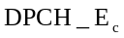 Average energy per PN chip for DPCH.
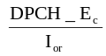 The ratio of the transmit energy per PN chip of the DPCH to the total transmit power spectral density at the Node B antenna connector.
DPDCH Dedicated Physical Data Channel
EIRP Effective Isotropic Radiated Power
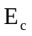 Average energy per PN chip.
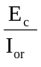 The ratio of the average transmit energy per PN chip for different fields or physical channels to the total transmit power spectral density.
FACH Forward Access Channel
FDD Frequency Division Duplex
FDR False transmit format Detection Ratio
F_{uw} Frequency of unwanted signal. This is specified in bracket in terms of an absolute frequency(s) or a frequency offset from the assigned channel frequency.
Information Data Rate
Rate of the user information, which must be transmitted over the Air Interface. For example, output rate of the voice codec.
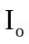 The total received power spectral density, including signal and interference, as measured at the UE antenna connector.
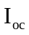 The power spectral density of a band limited white noise source (simulating interference from cells, which are not defined in a test procedure) as measured at the UE antenna connector.
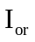 The total transmit power spectral density of the down link at the Node B antenna connector.
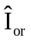 The received power spectral density of the down link as measured at the UE antenna connector.
MER Message Error Ratio
Node B A logical node responsible for radio transmission / reception in one or more cells to/from the User Equipment. Terminates the Iub interface towards the RNC
Orthogonal Channel Noise Simulator, a mechanism used to simulate the users or control signals on the other orthogonal channels of a downlink link.
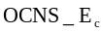 Average energy per PN chip for the OCNS.
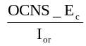 The ratio of the average transmit energy per PN chip for the OCNS to the total transmit power spectral density.
P-CCPCH Primary Common Control Physical Channel
Paging Channel
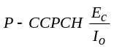 The ratio of the received P-CCPCH energy per chip to the total received power spectral density at the UE antenna connector.
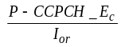 The ratio of the average transmit energy per PN chip for the P-CCPCH to the total transmit power spectral density.
P-CPICH Primary Common Pilot Channel
PICH Paging Indicator Channel
PPM Parts Per Million
RACH Random Access Channel
SCH Synchronization Channel consisting of Primary and Secondary synchronization channels
Secondary Common Control Physical Channel.
Average energy per PN chip for S-CCPCH.
SIR Signal to Interference ratio
SSDT Site Selection Diversity Transmission
STTD Space Time Transmit Diversity
TDD Time Division Duplexing
TFC Transport Format Combination
TFCI Transport Format Combination Indicator
TPC Transmit Power Control
TSTD Time Switched Transmit Diversity
UE User Equipment
UL Up Link (reverse link)
UTRA UMTS Terrestrial Radio Access

4 General

4.1 Test tolerances
The requirements given in the present document make no allowance for measurement uncertainty. The test specification 34.121 Annex F defines test tolerances. These test tolerances are individually calculated for each test. The test tolerances are then added to the limits in this specification to create test limits. The measurement results are compared against the test limits as defined by the shared risk principle.
The Shared Risk principle is defined in ETR 273 Part 1 sub-part 2 section 6.5.

4.2 Power Classes
For UE power classes 1 and 2, a number of RF parameter are not specified. It is intended that these are part of a later release.

5 Frequency bands and channel arrangement

5.1 General
The information presented in this subclause is based on a chip rate of 3.84 Mcps.
NOTE: Other chip rates may be considered in future releases.

5.2 Frequency bands
UTRA/FDD is designed to operate in either of the following paired bands:
(a) 1920 – 1980 MHz: Up-link (UE transmit, Node B receive)
2110 – 2170 MHz: Down-link (Node B transmit, UE receive)
(b)* 1850 – 1910 MHz: Up-link (UE transmit, Node B receive)
1930 – 1990 MHz: Down-link (Node B transmit, UE receive)
* Used in Region 2.
Additional allocations in ITU region 2 are FFS.
Deployment in other frequency bands is not precluded.

5.3 TX–RX frequency separation
(a) The minimum transmit to receive frequency separation is 134.8 MHz and the maximum value is 245.2 MHz and all UE(s) shall support a TX –RX frequency separation of 190 MHz when operating in the paired band defined in subclause 5.2(a).
(b) When operating in the paired band defined in subclause 5.2 (b), all UE(s) shall support a TX-RX frequency separation of 80 MHz.
(c) UTRA/FDD can support both fixed and variable transmit to receive frequency separation.
(d) The use of other transmit to receive frequency separations in existing or other frequency bands shall not be precluded.

5.4 Channel arrangement

5.4.1 Channel spacing
The nominal channel spacing is 5 MHz, but this can be adjusted to optimise performance in a particular deployment scenario.

5.4.2 Channel raster
The channel raster is 200 kHz, which means that the centre frequency must be an integer multiple of 200 kHz.

5.4.3 Channel number
The carrier frequency is designated by the UTRA Absolute Radio Frequency Channel Number (UARFCN). The value of the UARFCN in the IMT2000 band is defined as follows:

Table 5.1: UTRA Absolute Radio Frequency Channel Number
Uplink | N_{u} = 5 * F_{uplink} | 0.0 MHz ≤ F_{uplink} ≤ 3276.6 MHz  where F_{uplink} is the uplink frequency in MHz
Downlink | N_{d} = 5 * F_{downlink} | 0.0 MHz ≤ F_{downlink} ≤ 3276.6 MHz  where F_{downlink} is the downlink frequency in MHz

6 Transmitter characteristics

6.1 General
Unless detailed the transmitter characteristic are specified at the antenna connector of the UE. For UE with integral antenna only, a reference antenna with a gain of 0 dBi is assumed. Transmitter characteristics for UE(s) with multiple antennas/antenna connectors are FFS.
The UE antenna performance has a significant impact on system performance, and minimum requirements on the antenna efficiency are therefore intended to be included in future versions of the present document. It is recognised that different requirements and test methods are likely to be required for the different types of UE.
All the parameters in clause 6 are defined using the UL reference measurement channel (12.2 kbps) specified in subclause A.2.1 and unless stated with the UL power control ON

6.2 Transmit power

6.2.1 UE maximum output power
The following Power Classes define the maximum output power.

Table 6.1: UE Power Classes
Power Class | Maximum output power | Tolerance
1 | +33 dBm | +1/-3 dB
2 | +27 dBm | +1/-3 dB
3 | +24 dBm | +1/-3 dB
4 | +21 dBm | ± 2 dB

NOTE: The tolerance of the maximum output power is below the prescribed value even for the multi-code transmission mode.

6.3 Frequency Error
The UE modulated carrier frequency shall be accurate to within ±0.1 PPM observed over a period of one timeslot compared to the carrier frequency received from the Node B. These signals will have an apparent error due to Node B frequency error and Doppler shift. In the later case, signals from the Node B must be averaged over sufficient time that errors due to noise or interference are allowed for within the above ±0.1PPM figure. The UE shall use the same frequency source for both RF frequency generation and the chip clock.
Table 6.2: Frequency Error
AFC | Frequency stability
ON | within ± 0.1 PPM

6.4 Output power dynamics
Power control is used to limit the interference level.

6.4.1 Open loop power control
Open loop power control is the ability of the UE transmitter to sets its output power to a specific value. The open loop power control tolerance is given in Table 6.3

6.4.1.1 Minimum requirement
The UE open loop power is defined as the average power in a timeslot or ON power duration, whichever is available, and they are measured with a filter that has a Root-Raised Cosine (RRC) filter response with a roll off α = 0.22 and a bandwidth equal to the chip rate.

Table 6.3: Open loop power control tolerance
Normal conditions | ± 9 dB
Extreme conditions | ± 12 dB

6.4.2 Inner loop power control in the uplink
Inner loop power control in the Uplink is the ability of the UE transmitter to adjust its output power in accordance with one or more TPC commands received in the downlink.

6.4.2.1 Power control steps
The power control step is the change in the UE transmitter output power in response to a single TPC command, TPC_cmd, derived at the UE.

6.4.2.1.1 Minimum requirement
The UE transmitter shall have the capability of changing the output power with a step size of 1, 2 and 3 dB according to the value of Δ_{TPC} or Δ_{RP-TPC}, in the slot immediately after the TPC_cmd can be derived
(a) The transmitter output power step due to inner loop power control shall be within the range shown in Table 6.4.
(b) The transmitter average output power step due to inner loop power control shall be within the range shown in Table 6.5. Here a TPC_cmd group is a set of TPC_cmd values derived from a corresponding sequence of TPC commands of the same duration.
The inner loop power step is defined as the relative power difference between the average power of the original (reference) timeslot and the average power of the target timeslot, not including the transient duration. The transient duration is from 25μs before the slot boundary to 25μs after the slot boundary. The power is measured with a filter that has a Root-Raised Cosine (RRC) filter response with a roll off α = 0.22 and a bandwidth equal to the chip rate

Table 6.4: Transmitter power control range
TPC_ cmd | Transmitter power control range
TPC_ cmd | 1 dB step size |  | 2 dB step size |  | 3 dB step size
TPC_ cmd | Lower | Upper | Lower | Upper | Lower | Upper
+ 1 | +0.5 dB | +1.5 dB | +1 dB | +3 dB | +1.5 dB | +4.5 dB
0 | -0.5 dB | +0.5 dB | -0.5 dB | +0.5 dB | -0.5 dB | +0.5 dB
-1 | -0.5 dB | -1.5 dB | -1 dB | -3 dB | -1.5 dB | -4.5 dB

Table 6.5: Transmitter average power control range
TPC_ cmd group | Transmitter power control range after 10 equal TPC_ cmd groups |  |  |  | Transmitter power control range after 7 equal TPC_ cmd groups
TPC_ cmd group | 1 dB step size |  | 2 dB step size |  | 3 dB step size
TPC_ cmd group | Lower | Upper | Lower | Upper | Lower | Upper
+1 | +8 dB | +12 dB | +16 dB | +24 dB | +16 dB | +26 dB
0 | -1 dB | +1 dB | -1 dB | +1 dB | -1 dB | +1 dB
-1 | -8 dB | -12 dB | -16 dB | -24 dB | -16 dB | -26 dB
0,0,0,0,+1 | +6 dB | +14 dB | N/A | N/A | N/A | N/A
0,0,0,0,-1 | -6 dB | -14 dB | N/A | N/A | N/A | N/A

6.4.3 Minimum transmit output power
The minimum controlled output power of the UE is when the power control setting is set to a minimum value. This is when both the inner loop and open loop power control indicate a minimum transmit output power is required.

6.4.3.1 Minimum requirement
The minimum transmit power is defined as an averaged power in a time slot measured with a filter that has a Root-Raised Cosine (RRC) filter response with a roll off α = 0.22 and a bandwidth equal to the chip rate. The minimum transmit power shall be better than –50 dBm.

6.4.4 Out-of-synchronization handling of output power
The UE shall monitor the DPCCH quality in order to detect a loss of the signal on Layer 1, as specified in TS 25.214. The thresholds Q_{out} and Q_{in} specify at what DPCCH quality levels the UE shall shut its power off and when it shall turn its power on respectively. The thresholds are not defined explicitly, but are defined by the conditions under which the UE shall shut its transmitter off and turn it on, as stated in this subclause.

6.4.4.1 Minimum requirement
The parameters in Table 6.6 are defined using the DL reference measurement channel (12.2) kbps specified in subclause A.3.1 and with static propagation conditions.
Table 6.6: DCH parameters for test of Out-of-synch handling
Parameter | Unit |  | Value
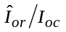 |  | dB | -1
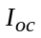 |  | dBm/3.84 MHz | -60
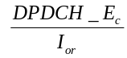 | dB |  | See figure 6.1: Before point A -16.6  After point A Not defined
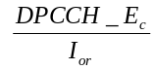 | dB |  | See figure 6.1
Information Data Rate | kbps |  | 12.2
TFCI | - |  | on

The conditions for when the UE shall shut its transmitter on and when it shall turn it on are defined by the parameters in Table 6.6 together with the DPCH power level as defined in Figure 6.1.
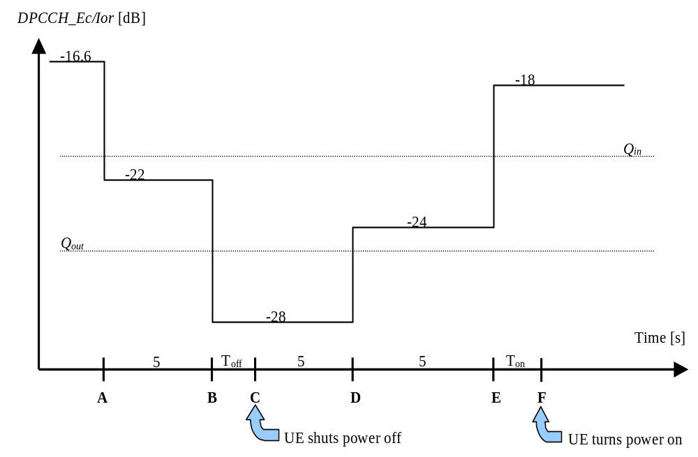
Figure 6.1: Conditions for out-of-synch handling in the UE. The indicated thresholds Q_{out} and Q_{in}
are only informative
The requirements for the UE are that:
- The UE shall not shut its transmitter off before point B.
- The UE shall shut its transmitter off before point C, which is T_{off} = 200 ms after point B.
- The UE shall not turn its transmitter on between points C and E.
- The UE shall turn its transmitter on before point F, which is T_{on} = 200 ms after point E.

6.5 Transmit ON/OFF power

6.5.1 Transmit OFF power
The transmit OFF power state is when the UE does not transmit except during UL compressed mode. This parameter is defined as the maximum output transmit power within the channel bandwidth when the transmitter is OFF.

6.5.1.1 Minimum requirement
The transmit OFF power is defined as an averaged power in a duration of at least a timeslot excluding any transient periods, measured with a filter that has a Root-Raised Cosine (RRC) filter response with a roll off α = 0.22 and a bandwidth equal to the chip rate. The requirement for the transmit OFF power shall be better than –56 dBm.

6.5.2 Transmit ON/OFF Time mask
The time mask for transmit ON/OFF defines the ramping time allowed for the UE between transmit OFF power and transmit ON power. Possible ON/OFF scenarios are RACH ,CPCH or UL compressed mode.

6.5.2.1 Minimum requirement
The transmit power levels versus time shall meet the mask specified in figure 6.2 for PRACH preambles and CPCH preambles, and the mask in figure 6.3 for all other cases. The signal is measured with a filter that has a Root-Raised Cosine (RRC) filter response with a roll off α = 0.22 and a bandwidth equal to the chip rate.
On power is defined as either case as follows. The specification depends on each possible case.
- First preamble of RACH/CPCH: Open loop accuracy (Table 6.3).
- During preamble ramping of the RACH/CPCH, and between final RACH/CPCH preamble and RACH/CPCH message part: Accuracy depending on size of the required power difference.(Table 6.7). The step in total transmitted power between final RACH/CPCH preamble and RACH/CPCH message (control part + data part) shall be rounded to the closest integer dB value. A power step exactly half-way between two integer values shall be rounded to the closest integer of greater magnitude.
- After transmission gaps in compressed mode: Accuracy as in Table 6.9.
- Power step to Maximum Power: Maximum power accuracy (Table 6.1).
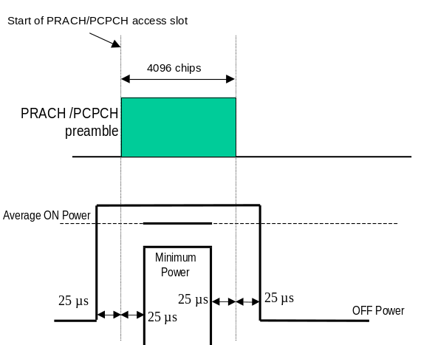
Figure 6.2: Transmit ON/OFF template for PRACH preambles and CPCH preambles
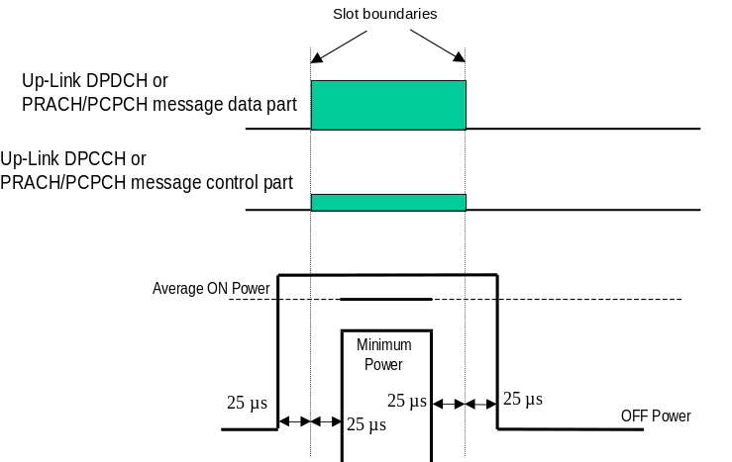

Figure 6.3: Transmit ON/OFF template for all other On/Off cases

Table 6.7: Transmitter power difference tolerance for RACH/CPCH preamble ramping, and between final RACH/CPCH preamble and RACH/CPCH message part
Power step size (Up or down)*  ΔP [dB] | Transmitter power difference tolerance [dB]
0 | +/- 1 dB
1 | +/- 1 dB
2 | +/- 1.5 dB
3 | +/- 2 dB
4 ≤ ΔP ≤ 10 | +/- 2.5 dB
11 ≤ ΔP ≤ 15 | +/- 3.5 dB
16 ≤ ΔP ≤ 20 | +/- 4.5 dB
21 ≤ ΔP | +/- 6.5 dB

Note *: Power step size for RACH/CPCH preamble ramping is from 1 to 8 dB with 1 dB steps.

6.5.3 Change of TFC
A change of TFC (Transport Format Combination) in uplink means that the power in the uplink varies according to the change in data rate. DTX, where the DPCH is turned off, is a special case of variable data, which is used to minimise the interference between UE(s) by reducing the UE transmit power when voice, user or control information is not present.

6.5.3.1 Minimum requirement
A change of output power is required when the TFC, and thereby the data rate, is changed. The ratio of the amplitude between the DPDCH codes and the DPCCH code will vary. The power step due to a change in TFC shall be calculated in the UE so that the power transmitted on the DPCCH shall follow the inner loop power control. The step in total transmitted power (DPCCH + DPDCH) shall then be rounded to the closest integer dB value. A power step exactly half-way between two integer values shall be rounded to the closest integer of greater magnitude. The accuracy of the power step, given the step size, is specified in Table 6.8. The power change due to a change in TFC is defined as the relative power difference between the average power of the original (reference) timeslot and the average power of the target timeslot, not including the transient duration. The transient duration is from 25μs before the slot boundary to 25μs after the slot boundary. The power is measured with a filter that has a Root-Raised Cosine (RRC) filter response with a roll off α = 0.22 and a bandwidth equal to the chip rate.

Table 6.8: Transmitter power step tolerance
Power step size (Up or down)  ΔP [dB] | Transmitter power step tolerance  [dB]
0 | +/- 0.5 dB
1 | +/- 0.5 dB
2 | +/- 1.0 dB
3 | +/- 1.5 dB
4 ≤ ΔP ≤ 10 | +/- 2.0 dB
11 ≤ ΔP ≤ 15 | +/- 3.0 dB
16 ≤ ΔP ≤ 20 | +/- 4.0 dB
21 ≤ ΔP | +/- 6.0 dB

The transmit power levels versus time shall meet the mask specified in Figure 6.4.
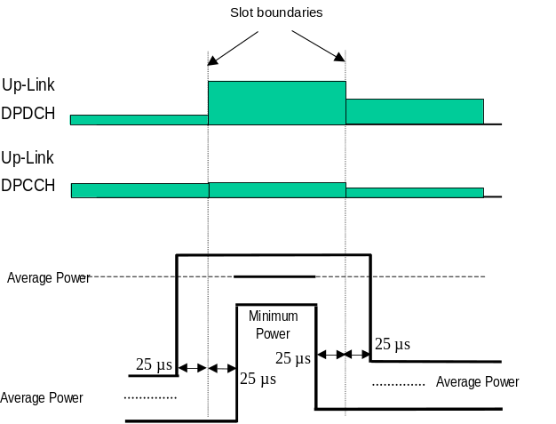

Figure 6.4: Transmit template during TFC change

6.5.4 Power setting in uplink compressed mode
Compressed mode in uplink means that the power in uplink is changed.

6.5.4.1 Minimum requirement
A change of output power is required during uplink compressed frames since the transmission of data is performed in a shorter interval. The ratio of the amplitude between the DPDCH codes and the DPCCH code will also vary. The power step due to compressed mode shall be calculated in the UE so that the energy transmitted on the pilot bits during each transmitted slot shall follow the inner loop power control.
Thereby, the power during compressed mode, and immediately afterwards, shall be such that the power on the DPCCH follows the steps due to inner loop power control combined with additional steps of 10Log₁₀(N_{pilot.prev} / N_{pilot.curr}) dB where N_{pilot.prev} is the number of pilot bits in the previously transmitted slot, and N_{pilot.curr} is the current number of pilot bits per slot.
The resulting step in total transmitted power (DPCCH +DPDCH) shall then be rounded to the closest integer dB value. A power step exactly half-way between two integer values shall be rounded to the closest integer of greatest magnitude. The accuracy of the power step, given the step size, is specified in Table 6.8 in subclause 6.5.3.1. The power step is defined as the relative power difference between the average power of the original (reference) timeslot and the average power of the target timeslot, when neither the original timeslot nor the reference timeslot are in a transmission gap. The transient duration is not included, and is from 25μs before the slot boundary to 25μs after the slot boundary. The relative power is measured with a filter that has a Root-Raised Cosine (RRC) filter response with a roll off α = 0.22 and a bandwidth equal to the chip rate.
In addition to any power change due to the ratio N_{pilot.prev} / N_{pilot.curr}, the average power of the DPCCH in the first slot after a compressed mode transmission gap shall differ from the average power in the last slot before the transmission gap by an amount Δ_{RESUME}, where Δ_{RESUME} is calculated as described in clause 5.1.2.3 of TS 25.214.
The resulting difference in the total transmitted power (DPCCH + DPDCH) shall then be rounded to the closest integer dB value. A power difference exactly half-way between two integer values shall be rounded to the closest integer of greatest magnitude. The accuracy of the resulting difference in the total transmitted power (DPCCH + DPDCH) after a transmission gap of up to 14 slots shall be as specified in Table 6.9.
Table 6.9: Transmitter power difference tolerance after a transmission gap of up to 14 slots
Tolerance on required difference in total transmitter power after a transmission gap
+/- 3 dB

The power difference is defined as the relative power difference between the average power of the original (reference) timeslot before the transmission gap and the average power of the target timeslot after the transmission gap, not including the transient durations. The transient durations at the start and end of the transmission gaps are each from 25μs before the slot boundary to 25μs after the slot boundary. The relative power is measured with a filter that has a Root-Raised Cosine (RRC) filter response with a roll off α = 0.22 and a bandwidth equal to the chip rate.
The transmit power levels versus time shall meet the mask specified in figure 6.5
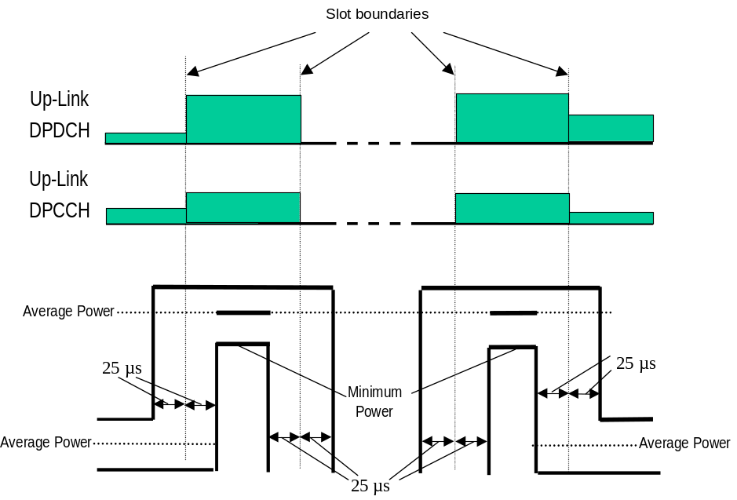

Figure 6.5: Transmit template during Compressed mode

6.6 Output RF spectrum emissions

6.6.1 Occupied bandwidth
Occupied bandwidth is a measure of the bandwidth containing 99 % of the total integrated power of the transmitted spectrum, centered on the assigned channel frequency. The occupied channel bandwidth shall be less than 5 MHz based on a chip rate of 3.84 Mcps.

6.6.2 Out of band emission
Out of band emissions are unwanted emissions immediately outside the nominal channel resulting from the modulation process and non-linearity in the transmitter but excluding spurious emissions. This out of band emission limit is specified in terms of a spectrum emission mask and Adjacent Channel Leakage power Ratio.

6.6.2.1 Spectrum emission mask
The spectrum emission mask of the UE applies to frequencies, which are between 2.5 MHz and 12.5 MHz away from the UE centre carrier frequency. The out of channel emission is specified relative to the UE output power measured in a 3.84 MHz bandwidth.

6.6.2.1.1 Minimum requirement
The power of any UE emission shall not exceed the levels specified in Table 6.10

Table 6.10: Spectrum Emission Mask Requirement
Frequency offset from carrier Δf | Minimum requirement | Measurement bandwidth
2.5 - 3.5 MHz | -35 -15*(Δf – 2.5) dBc | 30 kHz *
3.5 - 7.5 MHz | -35- 1*(Δf-3.5) dBc | 1 MHz *
7.5 - 8.5 MHz | -39 - 10*(Δf – 7.5) dBc | 1 MHz *
8.5 - 12.5 MHz | -49 dBc | 1 MHz *

Note *:
- The first and last measurement position with a 30 kHz filter is 2.515 MHz and 3.485 MHz.
- The first and last measurement position with a 1 MHz filter is 4 MHz and 12 MHz. As a general rule, the resolution bandwidth of the measuring equipment should be equal to the measurement bandwidth. To improve measurement accuracy, sensitivity and efficiency, the resolution bandwidth can be different from the measurement bandwidth. When the resolution bandwidth is smaller than the measurement bandwidth, the result should be integrated over the measurement bandwidth.
- The lower limit shall be –50 dBm/3.84 MHz or which ever is higher.

6.6.2.2 Adjacent Channel Leakage power Ratio (ACLR)
Adjacent Channel Leakage power Ratio (ACLR) is the ratio of the transmitted power to the power measured in an adjacent channel. Both the transmitted power and the adjacent channel power are measured with a filter that has a Root-Raised Cosine (RRC) filter response with roll-off α =0.22 and a bandwidth equal to the chip rate.

6.6.2.2.1 Minimum requirement
If the adjacent channel power is greater than –50dBm then the ACLR shall be higher than the value specified in Table 6.11.

Table 6.11: UE ACLR
Power Class | Adjacent channel relative to UE channel | ACLR limit
3 | + 5 MHz or – 5 MHz | 33 dB
3 | + 10 MHz or – 10 MHz | 43 dB
4 | + 5 MHz or – 5 MHz | 33 dB
4 | + 10 MHz or –10 MHz | 43 dB

NOTE 1: The requirement shall still be met in the presence of switching transients.
NOTE 2: The ACLR requirements reflect what can be achieved with present state of the art technology.
NOTE 3: Requirement on the UE shall be reconsidered when the state of the art technology progresses.

6.6.3 Spurious emissions
Spurious emissions are emissions which are caused by unwanted transmitter effects such as harmonics emission, parasitic emission, intermodulation products and frequency conversion products, but exclude out of band emissions.
The frequency boundary and the detailed transitions of the limits between the requirement for out band emissions and spectrum emissions are based on ITU-R Recommendations SM.329.

6.6.3.1 Minimum requirement
These requirements are only applicable for frequencies, which are greater than 12.5 MHz away from the UE centre carrier frequency.

Table 6.12: General spurious emissions requirements
Frequency Bandwidth | Resolution Bandwidth | Minimum requirement
9 kHz ≤ f < 150 kHz | 1 kHz | -36 dBm
150 kHz ≤ f < 30 MHz | 10 kHz | -36 dBm
30 MHz ≤ f < 1000 MHz | 100 kHz | -36 dBm
1 GHz ≤ f < 12.75 GHz | 1 MHz | -30 dBm

Table 6.13: Additional spurious emissions requirements
Frequency Bandwidth | Resolution Bandwidth | Minimum requirement
1893.5 MHz <f<1919.6 MHz | 300 kHz | -41 dBm
925 MHz ≤ f ≤ 935 MHz | 100 kHz | -67 dBm *
935 MHz < f ≤ 960 MHz | 100 kHz | -79 dBm *
1805 MHz ≤ f ≤ 1880 MHz | 100 kHz | -71 dBm *

NOTE *: The measurements are made on frequencies which are integer multiples of 200 kHz. As exceptions, up to five measurements with a level up to the applicable requirements defined in Table 6.12 are permitted for each UARFCN used in the measurement.

6.7 Transmit intermodulation
The transmit intermodulation performance is a measure of the capability of the transmitter to inhibit the generation of signals in its non linear elements caused by presence of the wanted signal and an interfering signal reaching the transmitter via the antenna.

6.7.1 Minimum requirement
User Equipment(s) transmitting in close vicinity of each other can produce intermodulation products, which can fall into the UE, or Node B receive band as an unwanted interfering signal. The UE intermodulation attenuation is defined by the ratio of the output power of the wanted signal to the output power of the intermodulation product when an interfering CW signal is added at a level below the wanted signal. Both the wanted signal power and the IM product power are measured with a filter that has a Root-Raised Cosine (RRC) filter response with roll-off α =0.22 and a bandwidth equal to the chip rate.
The requirement of transmitting intermodulation for a carrier spacing of 5 MHz is prescribed in Table 6.14.

Table 6.14: Transmit Intermodulation
Interference Signal Frequency Offset | 5MHz | 10MHz
Interference CW Signal Level | -40dBc
Intermodulation Product | -31dBc | -41dBc

6.8 Transmit modulation

6.8.1 Transmit pulse shape filter
The transmit pulse shaping filter is a root-raised cosine (RRC) with roll-off α =0.22 in the frequency domain. The impulse response of the chip impulse filter RC₀(t) is:
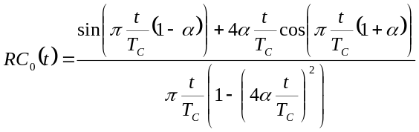

Where the roll-off factor α =0.22 and the chip duration is

6.8.2 Error Vector Magnitude
The Error Vector Magnitude is a measure of the difference between the measured waveform and the theoretical modulated waveform (the error vector). It is the square root of the ratio of the mean error vector power to the mean reference signal power expressed as a %. The measurement interval is one power control group (timeslot).

6.8.2.1 Minimum requirement
The Error Vector Magnitude shall not exceed 17.5 % for the parameters specified in Table 6.15.

Table 6.15: Parameters for Error Vector Magnitude/Peak Code Domain Error
Parameter | Unit | Level
UE Output Power | dBm | ≥ –20
Operating conditions |  | Normal conditions
Power control step size | dB | 1

6.8.3 Peak code domain error
The Peak Code Domain Error is computed by projecting power of the error vector (as defined in 6.8.2) onto the code domain at a specific spreading factor. The Code Domain Error for every code in the domain is defined as the ratio of the mean power of the projection onto that code, to the mean power of the composite reference waveform. This ratio is expressed in dB. The Peak Code Domain Error is defined as the maximum value for the Code Domain Error for all codes. The measurement interval is one power control group (timeslot).
The requirement for peak code domain error is only applicable for multi-code transmission.

6.8.3.1 Minimum requirement
The peak code domain error shall not exceed -15 dB at spreading factor 4 for the parameters specified in Table 6.15 . The requirements are defined using the UL reference measurement channel specified in subclause A.2.5.

7 Receiver characteristics

7.1 General
Unless otherwise stated the receiver characteristics are specified at the antenna connector of the UE. For UE(s) with an integral antenna only, a reference antenna with a gain of 0 dBi is assumed. UE with an integral antenna may be taken into account by converting these power levels into field strength requirements, assuming a 0 dBi gain antenna. Receiver characteristics for UE(s) with multiple antennas/antenna connectors are FFS.
The UE antenna performance has a significant impact on system performance, and minimum requirements on the antenna efficiency are therefore intended to be included in future versions of the present document. It is recognised that different requirements and test methods are likely to be required for the different types of UE.
All the parameters in clause 7 are defined using the DL reference measurement channel (12.2 kbps) specified in subclause A.3.1 and unless stated are with DL power control OFF.

7.2 Diversity characteristics
A suitable receiver structure using coherent reception in both channel impulse response estimation and code tracking procedures is assumed. Three forms of diversity are considered to be available in UTRA/FDD.

Table 7.1: Diversity characteristics for UTRA/FDD
Time diversity | Channel coding and interleaving in both up link and down link
Multi-path diversity | Rake receiver or other suitable receiver structure with maximum combining. Additional processing elements can increase the delay-spread performance due to increased capture of signal energy.
Antenna diversity | Antenna diversity with maximum ratio combing in the Node B and optionally in the UE. Possibility for downlink transmit diversity in the Node B.

7.3 Reference sensitivity level
The reference sensitivity is the minimum receiver input power measured at the antenna port at which the Bit Error Ratio (BER) does not exceed a specific value.

7.3.1 Minimum requirement
The BER shall not exceed 0.001 for the parameters specified in Table 7.2.

Table 7.2: Test parameters for reference sensitivity
Parameter | Unit | Level
DPCH_Ec | dBm/3.84 MHz | -117
Î_{or} | dBm/3.84 MHz | -106.7

7.4 Maximum input level
This is defined as the maximum receiver input power at the UE antenna port, which does not degrade the specified BER performance.

7.4.1 Minimum requirement
The BER shall not exceed 0.001 for the parameters specified in Table 7.3.

Table 7.3: Maximum input level
Parameter | Unit | Level
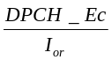 | dB | -19
Î_{or} | dBm/3.84 MHz | -25

NOTE: Since the spreading factor is large (10log(SF)=21dB), the majority of the total input signal consists of the OCNS interference. The structure of OCNS signal is defined in Annex C.3.2.

7.5 Adjacent Channel Selectivity (ACS)
Adjacent Channel Selectivity (ACS) is a measure of a receiver’s ability to receive a W-CDMA signal at its assigned channel frequency in the presence of an adjacent channel signal at a given frequency offset from the centre frequency of the assigned channel. ACS is the ratio of the receive filter attenuation on the assigned channel frequency to the receive filter attenuation on the adjacent channel(s).

7.5.1 Minimum requirement
The ACS shall be better than the value indicated in Table 7.4 for the test parameters specified in Table 7.5 where the BER shall not exceed 0.001.

Table 7.4: Adjacent Channel Selectivity
Power Class | Unit | ACS
3 | dB | 33
4 | dB | 33

Table 7.5: Test parameters for Adjacent Channel Selectivity
Parameter | Unit | Level
DPCH_Ec | dBm/3.84 MHz | -103
Î_{or} | dBm/3.84 MHz | -92.7
I_{oac} (modulated) | dBm/3.84 MHz | -52
F_{uw} (offset) | MHz | +5 or -5

Note The I_{oac} (modulated) signal consist of common channels needed for tests and 16 dedicated data channel. The channelization codes for data channels are chosen optimally to reduce peak to average ratio (PAR). All dedicated channels user data is uncorrelated to each other.

7.6 Blocking characteristics
The blocking characteristic is a measure of the receiver’s ability to receive a wanted signal at its assigned channel frequency in the presence of an unwanted interferer on frequencies other than those of the spurious response or the adjacent channels, without this unwanted input signal causing a degradation of the performance of the receiver beyond a specified limit. The blocking performance shall apply at all frequencies except those at which a spurious response occur.

7.6.1 Minimum requirement
The BER shall not exceed 0.001 for the parameters specified in Table 7.6 and Table 7.7. For Table 7.7 up to (24) exceptions are allowed for spurious response frequencies in each assigned frequency channel when measured using a 1 MHz step size.

Table 7.6: In-band blocking
Parameter | Unit | Offset | Offset
DPCH_Ec | dBm/3.84 MHz | -114 | -114
Î_{or} | dBm/3.84 MHz | -103.7 | -103.7
I_{blocking} (modulated) | dBm/3.84 MHz | -56 | -44
F_{uw} (offset) | MHz | +10 or –10 | +15 or –15

Note: I_{blocking} (modulated) consist of common channels and 16 dedicated data channel. The channelization codes for data channels are chosen optimally to reduce peak to average ratio (PAR). All dedicated channels user data is uncorrelated to each other.

Table 7.7: Out of band blocking
Parameter | Unit | Band 1 | Band 2 | Band 3
DPCH_Ec | dBm/3.84 MHz | -114 | -114 | -114
Î_{or} | dBm/3.84 MHz | -103.7 | -103.7 | -103.7
I_{blocking} (CW) | dBm | -44 | -30 | -15
F_{uw}  For operation in frequency bands as defined in subclause 5.2(a) | MHz | 2050<f <2095  2185<f <2230 | 2025 <f <2050  2230 <f <2255 | 1< f <2025  2255<f<12750
F_{uw}  For operation in frequency bands as defined in subclause 5.2(b) | MHz | 1870<f <1915  2005<f <2050 | 1845 <f <1870  2050 <f <2075 | 1< f <1845  2075<f<12750

Note:
- For operation in bands referenced in 5.2(a), from 2095<f<2110 MHz and 2170<f<2185 MHz, the appropriate in-band blocking or adjacent channel selectivity in subclause 7.5.1 shall be applied.
- For operation in bands referenced in 5.2(b), 1915<f<1930 MHz and 1990<f<2005 MHz, the appropriate in-band blocking or adjacent channel selectivity in subclause 7.5.1 shall be applied.

7.7 Spurious response
Spurious response is a measure of the receiver’s ability to receive a wanted signal on its assigned channel frequency without exceeding a given degradation due to the presence of an unwanted CW interfering signal at any other frequency at which a response is obtained i.e. for which the blocking limit is not met.

7.7.1 Minimum requirement
The BER shall not exceed 0.001 for the parameters specified in Table 7.8.

Table 7.8: Spurious Response
Parameter | Unit | Level
DPCH_Ec | dBm/3.84 MHz | -114
Î_{or} | dBm/3.84 MHz | -103.7
I_{blocking} (CW) | dBm | -44
F_{uw} | MHz | Spurious response frequencies

7.8 Intermodulation characteristics
Third and higher order mixing of the two interfering RF signals can produce an interfering signal in the band of the desired channel. Intermodulation response rejection is a measure of the capability of the receiver to receiver a wanted signal on its assigned channel frequency in the presence of two or more interfering signals which have a specific frequency relationship to the wanted signal.

7.8.1 Minimum requirement
The BER shall not exceed 0.001 for the parameters specified in Table 7.9.

Table 7.9: Receive intermodulation characteristics
Parameter | Unit | Level
DPCH_Ec | dBm/3.84 MHz | -114
Î_{or} | dBm/3.84 MHz | -103.7
I_{ouw1} (CW) | dBm | -46
I_{ouw2} (modulated) | dBm/3.84 MHz | -46
F_{uw1} (offset) | MHz | 10 | -10
F_{uw2} (offset) | MHz | 20 | -20

Note: I_{ouw2} (modulated) consist of common channels and 16 dedicated data channel. The channelization codes for data channels are chosen optimally to reduce peak to average ratio (PAR). All dedicated channels user data is uncorrelated to each other.

7.9 Spurious emissions
The spurious emissions power is the power of emissions generated or amplified in a receiver that appear at the UE antenna connector.

7.9.1 Minimum requirement
The power of any narrow band CW spurious emission shall not exceed the maximum level specified in Table 7.10 and Table 7.11
Table 7.10: General receiver spurious emission requirements
Frequency Band | Measurement  Bandwidth | Maximum level | Note
9kHz ≤ f < 1GHz | 100 kHz | -57 dBm
1GHz ≤ f ≤ 12.75 GHz | 1 MHz | -47 dBm

Table 7.11: Additional receiver spurious emission requirements
Frequency Band | Measurement  Bandwidth | Maximum level | Note
1920 MHz ≤ f ≤ 1980 MHz | 3.84 MHz | -60 dBm | Mobile transmit band in  URA_PCH, Cell_PCH and idle state
2110 MHz ≤ f ≤ 2170 MHz | 3.84 MHz | -60 dBm | Mobile receive band

8 Performance requirement

8.1 General
The performance requirements for the UE in this subclause are specified for the measurement channels specified in Annex A, the propagation conditions specified in Annex B and the Down link Physical channels specified in Annex C. Unless stated DL power control is OFF.

8.2 Demodulation in static propagation conditions

8.2.1 Demodulation of Paging Channel (PCH)
The receive characteristics of the paging channel in the static environment is determined by the Paging Message Error Ratio (MER). MER is measured at the data rate specified for the paging channel. The UE sleep mode has an upper limit after which it must up wake up and demodulate the paging channel and associated paging messages.

8.2.1.1 Minimum requirement
For the parameters specified in Table 8.1 the MER shall not exceed the piece-wise linear MER curve specified by the points in Table 8.2.

Table 8.1: PCH parameters in static propagation conditions
Parameter | Unit | Value
Phase reference |  | P-CPICH
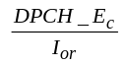 | dB
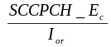 | dB
 | dB | -1
 | dBm/3.84 MHz | -60
Paging Data Rate

Table 8.2: PCH requirement in static propagation conditions
TBD | MER
TBD | TBD
TBD | TBD
TBD | TBD

8.2.2 Demodulation of Forward Access Channel (FACH)
The receive characteristics of the Forward Access Channel (FACH) in the static environment are determined by the average message error Ratio (MER). MER is measured at the data rate specified for the FACH.

8.2.2.1 Minimum requirement
For the parameters specified in Table 8.3 the MER shall not exceed the piece-wise linear MER curve specified by the points in table 8.4.

Table 8.3: FACH parameters in static propagation conditions
Parameter | Unit | Value
Phase reference |  | P-CPICH
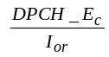 | dB
 | dB
 | dB | -1
 | dBm/3.84 MHz | -60
Control Data Rate | ?

Table 8.4: FACH requirements in static propagation conditions
TBD | MER
TBD | TBD
TBD | TBD
TBD | TBD

8.2.3 Demodulation of Dedicated Channel (DCH)
The receive characteristic of the Dedicated Channel (DCH) in the static environment is determined by the Block Error Ratio (BLER). BLER is specified for each individual data rate of the DCH. DCH is mapped into the Dedicated Physical Channel (DPCH).

8.2.3.1 Minimum requirement
For the parameters specified in Table 8.5 the average downlink 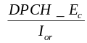 power shall be below the specified value for the BLER shown in Table 8.6. These requirements are applicable for TFCS size 16.

Table 8.5: DCH parameters in static propagation conditions
Parameter | Unit | Test 1 |  | Test 2 | Test 3 | Test 4
Phase reference |  |  | P-CPICH
 | dB |  | -1
 | dBm/3.84 MHz |  | -60
Information Data Rate | kbps | 12.2 |  | 64 | 144 | 384

Table 8.6: DCH requirements in static propagation conditions
Test Number | 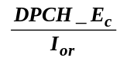 | BLER
1 | -16.6 dB | 10⁻²
2 | -13.1 dB | 10⁻¹
2 | -12.8 dB | 10⁻²
3 | -9.9 dB | 10⁻¹
3 | -9.8 dB | 10⁻²
4 | -5.6 dB | 10⁻¹
4 | -5.5 dB | 10⁻²

8.3 Demodulation of DCH in multi-path fading propagation conditions

8.3.1 Single Link Performance
The receive characteristics of the Dedicated Channel (DCH) in different multi-path fading environments are determined by the Block Error Ratio (BLER) values. BLER is measured for the each of the individual data rate specified for the DPCH. DCH is mapped into in Dedicated Physical Channel (DPCH).

8.3.1.1 Minimum requirement
For the parameters specified in Table 8.7, 8.9 , 8.11 and 8.13 the average downlink power shall be below the specified value for the BLER shown in Table 8.8, 8.10, 8.12 and 8.14. These requirements are applicable for TFCS size 16.

Table 8.7: Test Parameters for DCH in multi-path fading propagation conditions (Case 1)
Parameter | Unit |  |  | Test 1 |  |  |  | Test 2 |  | Test 3 |  | Test 4
Phase reference |  |  |  |  | P-CPICH
 |  | dB |  |  | 9
 |  | dBm/3.84 MHz |  |  | -60
Information Data Rate |  |  | kbps |  |  | 12.2 | 64 |  | 144 |  | 384

Table 8.8: Test requirements for DCH in multi-path fading propagation conditions (Case 1)
Test Number |  | BLER
1 | -15.0 dB | 10⁻²
2 | -13.9 dB | 10⁻¹
2 | -10.0 dB | 10⁻²
3 | -10.6 dB | 10⁻¹
3 | -6.8 dB | 10⁻²
4 | -6.3 dB | 10⁻¹
4 | -2.2 dB | 10⁻²

Table 8.9: DCH parameters in multi-path fading propagation conditions (Case 2)
Parameter | Unit |  |  | Test 5 |  |  | Test 6 |  | Test 7 | Test 8
Phase reference |  |  |  |  | P-CPICH
 |  | dB |  |  | -3 |  |  | -3 | 3 | 6
 |  |  | dBm/3.84 MHz |  |  | -60
Information Data Rate | kbps |  |  | 12.2 |  |  | 64 |  | 144 | 384

Table 8.10: DCH requirements in multi-path fading propagation (Case 2)
Test Number |  | BLER
5 | -7.7 dB | 10⁻²
6 | -6.4 dB | 10⁻¹
6 | -2.7 dB | 10⁻²
7 | -8.1 dB | 10⁻¹
7 | -5.1 dB | 10⁻²
8 | -5.5 dB | 10⁻ ¹
8 | -3.2 dB | 10⁻²

Table 8.11: DCH parameters in multi-path fading propagation conditions (Case 3)
Parameter | Unit |  | Test 9 |  | Test 10 |  | Test 11 |  | Test 12
Phase reference |  | P-CPICH
 | dB | -3 |  | -3 |  | 3 |  | 6
 | dBm/3.84 MHz |  | -60
Information Data Rate | kbps |  | 12.2 |  | 64 |  | 144 |  | 384

Table 8.12: DCH requirements in multi-path fading propagation conditions (Case 3)
Test Number |  | BLER
9 | -11.8 dB | 10⁻²
10 | -8.1 dB | 10⁻¹
10 | -7.4 dB | 10⁻²
10 | -6.8 dB | 10⁻³
11 | -9.0 dB | 10⁻¹
11 | -8.5 dB | 10⁻²
11 | -8.0 dB | 10⁻³
12 | -5.9 dB | 10⁻¹
12 | -5.1 dB | 10⁻²
12 | -4.4 dB | 10⁻³

Table 8.13: DCH parameters in multi-path fading propagation conditions (Case 1) with S-CPICH
Parameter | Unit |  | Test 13 | Test 14 | Test 15 | Test 16
Phase reference |  | S-CPICH
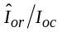 | dB | 9
 | dBm/3.84 MHz |  | -60
Information Data Rate | kbps |  | 12.2 | 64 | 144 | 384

Table 8.14: DCH requirements in multi-path fading propagation conditions (Case 1) with S-CPICH
Test Number | 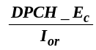 | BLER
13 | -15.0 dB | 10⁻²
14 | -13.9 dB | 10⁻¹
14 | -10.0 dB | 10⁻²
15 | -10.6 dB | 10⁻¹
15 | -6.8 dB | 10⁻²
16 | -6.3 dB | 10⁻¹
16 | -2.2 dB | 10⁻²

8.4 Demodulation of DCH in moving propagation conditions

8.4.1 Single link performance
The receive single link performance of the Dedicated Channel (DCH) in dynamic moving propagation conditions are determined by the Block Error Ratio (BLER) values. BLER is measured for the each of the individual data rate specified for the DPCH. DCH is mapped into Dedicated Physical Channel (DPCH).

8.4.1.1 Minimum requirement
For the parameters specified in Table 8.15 the average downlink power shall be below the specified value for the BLER shown in Table 8.16.

Table 8.15: DCH parameters in moving propagation conditions
Parameter | Unit |  | Test 1 |  | Test 2
Phase reference |  |  |  | P-CPICH
 |  | dB |  | -1
 |  | dBm/3.84 MHz |  | -60
Information Data Rate | kbps |  | 12.2 |  | 64

Table 8.16: DCH requirements in moving propagation conditions
Test Number |  | BLER
1 | -14.5 dB | 10⁻²
2 | -10.9 dB | 10⁻²

8.5 Demodulation of DCH in birth-death propagation conditions

8.5.1 Single link performance
The receive single link performance of the Dedicated Channel (DCH) in dynamic birth-death propagation conditions are determined by the Block Error Ratio (BLER) values. BER is measured for the each of the individual data rate specified for the DPCH. DCH is mapped into Dedicated Physical Channel (DPCH).

8.5.1.1 Minimum requirement
For the parameters specified in Table 8.17 the average downlink power shall be below the specified value for the BLER shown in Table 8.18.
Table 8.17: DCH parameters in birth-death propagation conditions
Parameter | Unit |  | Test 1 |  | Test 2
Phase reference |  |  |  | P-CPICH
 |  | dB |  | -1
 |  | dBm/3.84 MHz |  | -60
Information Data Rate | kbps |  | 12.2 |  | 64

Table 8.18: DCH requirements in birth-death propagation conditions
Test Number |  | BLER
1 | -12.6 dB | 10⁻²
2 | -8.7 dB | 10⁻²

8.6 Demodulation of DCH in downlink Transmit diversity modes

8.6.1 Demodulation of DCH in open-loop transmit diversity mode
The receive characteristic of the Dedicated Channel (DCH) in open loop transmit diversity mode is determined by the Block Error Ratio (BLER). DCH is mapped into in Dedicated Physical Channel (DPCH).

8.6.1.1 Minimum requirement
For the parameters specified in Table 8.19 the average downlink power shall be below the specified value for the BLER shown in Table 8.20.
Table 8.19: Test parameters for DCH reception in an open loop transmit diversity scheme.
(Propagation condition: Case 1)
Parameter | Unit | Test 1
Phase reference |  | P-CPICH
 | dB | 9
 | dBm/3.84 MHz | -60
Information data rate | kbps | 12.2

Table 8.20: Test requirements for DCH reception in open loop transmit diversity scheme
Test Number | (antenna 1/2) | BLER
1 | [-16.8 dB] | 10⁻²

8.6.2 Demodulation of DCH in closed loop transmit diversity mode
The receive characteristic of the dedicated channel (DCH) in closed loop transmit diversity mode is determined by the Block Error Ratio (BLER). DCH is mapped into in Dedicated Physical Channel (DPCH).

8.6.2.1 Minimum requirement
For the parameters specified in Table 8.21 the average downlink power shall be below the specified value for the BLER shown in Table 8.22.
Table 8.21: Test Parameters for DCH Reception in closed loop transmit diversity mode
(Propagation condition: Case 1)
Parameter | Unit | Test 1  (Mode 1) | Test 2  (Mode 2)
 | dB | 9 | 9
 | dBm/3.84 MHz | -60 | -60
Information data rate | kbps | 12.2 | 12.2
Feedback error rate | % | 4 | 4

Table 8.22: Test requirements for DCH reception in closed loop transmit diversity mode
Test Number | (see note) | BLER
1 | -18.0 dB | 10⁻²
2 | -18.3 dB | 10⁻²
NOTE: This is the total power from both antennas. Power sharing between antennas are feedback mode dependent as specified in TS25.214.

8.6.3 Demodulation of DCH in Site Selection Diversity Transmission Power Control mode
The bit error characteristics of UE receiver is determined in Site Selection Diversity Transmission power control (SSDT) mode. Two Node B emulators are required for this performance test. The delay profiles of signals received from different Node Bs are assumed to be the same but time shifted by 10 chip periods (2604 ns).

8.6.3.1 Minimum requirements
The downlink physical channels and their relative power to Ior are the same as those specified in clause C.3.2 irrespective of Node Bs and the test cases. DPCH_Ec/Ior value applies whenever DPDCH in the cell is transmitted. In Test 1 and Test 3, the received powers at UE from two Node Bs are the same, while 3dB offset is given to one that comes from one of Node Bs for Test 2 and Test 4 as specified in Table 8.23.
For the parameters specified in Table 8.23 the average downlink power shall be below the specified value for the BLER shown in Table 8.24.
Table 8.23: DCH parameters in multi-path propagation conditions during SSDT mode
(Propagation condition: Case 1)
Parameter | Unit | Test 1 | Test 2 | Test 3 | Test 4
Phase reference |  | P-CPICH
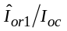 | dB | 0 | -3 | 0 | 0
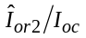 | dB | 0 | 0 | 0 | -3
 | dBm/3.84 MHz | -60
Information Data Rate | kbps | 12.2 | 12.2 | 12.2 | 12.2
Feedback error rate* | % | 4 | 4 | 4 | 4
Number of FBI bits assigned to "S" Field |  | 1 | 1 | 2 | 2
Code word Set |  | Long | Long | Short | Short

*NOTE: Feedback error rate is defined as FBI bit error rate

Table 8.24: DCH requirements in multi-path propagation conditions during SSDT Mode
Test Number |  | BLER
1 | -7.5 dB | 10⁻²
2 | -6.5 dB | 10⁻²
3 | -10.5 dB | 10⁻²
4 | -9.2 dB | 10⁻²

8.7 Demodulation in Handover conditions

8.7.1 Demodulation of DCH in Inter-Cell Soft Handover
The bit error rate characteristics of UE is determined during an inter-cell soft handover. During the soft handover a UE receives signals from different cells. A UE has to be able to demodulate two PCCPCH channels and to combine the energy of DCH channels. Delay profiles of signals received from different cells are assumed to be the same but time shifted by 10 chips.
The receive characteristics of the different channels during inter-cell handover are determined by the average Block Error Ratio (BLER) values.

8.7.1.1 Minimum requirement
For the parameters specified in Table 8.25 the average downlink power shall be below the specified value for the BLER shown in Table 8.26.
Table 8.25: DCH parameters in multi-path propagation conditions during Soft Handoff (Case 3)
Parameter | Unit |  |  | Test 1 |  |  |  | Test 2 | Test 3 |  | Test 4
Phase reference |  |  |  |  | P-CPICH
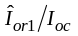 and 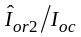 |  | dB |  |  | 0 |  | 0 |  |  | 3 |  | 6
 |  |  | dBm/3.84 MHz |  |  | -60
Information data Rate |  | kbps |  |  | 12.2 |  | 64 |  |  | 144 |  | 384

Table 8.26: DCH requirements in multi-path propagation conditions during Soft Handoff (Case 3)
Test Number |  | BLER
1 | -15.2 dB | 10⁻²
2 | -11.8 dB | 10⁻¹
2 | -11.3 dB | 10⁻²
3 | -9.6 dB | 10⁻¹
3 | -9.2 dB | 10⁻²
4 | -6.0 dB | 10⁻¹
4 | -5.5 dB | 10⁻²

8.7.2 Combining of TPC commands from radio links of different radio link sets

8.7.2.1. Minimum requirement
Test parameters are specified in Table 8.27. The delay profiles of the signals received from the different cells are the same but time-shifted by 10 chips.
For Test 1, the uplink power changes between adjacent slots shall be as shown in Table 8.28 over the 4 consecutive slots. Note that this case is without an additional noise source I_{oc}.
For Test 2, the Cell1 and Cell2 TPC patterns are repeated a number of times. If the transmitted power of a given slot is increased compared to the previous slot, then a variable "Transmitted power UP" is increased by one, otherwise a variable "Transmitted power DOWN" is increased by one. The requirements for "Transmitted power UP" and "Transmitted power DOWN" are shown in Table 8.28a.
Table 8.27: Parameters for TPC command combining
Parameter |  | Unit | Test 1 |  | Test 2
Phase reference | - |  | P-CPICH
DPCH_Ec/Ior | dB |  | -12
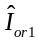and 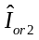 | dBm/3.84 MHz |  | -60
 | dBm/3.84 MHz |  | - | -60
Power-Control-Algorithm | - |  | Algorithm 1
Cell 1 TPC commands over 4 slots | - |  | {0,0,1,1}
Cell 2 TPC commands over 4 slots | - |  | {0,1,0,1}
Information data Rate | kbps |  | 12.2
Propagation condition | - |  | Static without AWGN source |  | Multi-path fading case 3

Table 8.28: Test requirements for Test 1
Test Number | Required power changes over the 4 consecutive slots
1 | Down, Down, Down, Up

Table 8.28a: Requirements for Test 2
Test Number | Ratio  (Transmitted power UP) / (Total number of slots) | Ratio  (Transmitted power DOWN) / (Total number of slots)
2 | ≥0.25 | ≥0.5

8.8 Power control in downlink
Power control in the downlink is the ability of the UE receiver to converge to required link quality set by the network while using as low power as possible in downlink . If a BLER target has been assigned to a DCCH (See Annex A.3), then it has to be such that outer loop is based on DTCH and not on DCCH.

8.8.1 Power control in the downlink, constant BLER target

8.8.1.1 Minimum requirements
For the parameters specified in Table 8.29 the downlink power measured values, which are averaged over one slot, shall be below the specified value in Table 8.30 more than 90% of the time. BLER shall be as shown in Table 8.30. Power control in downlink is ON during the test.
Table 8.29: Test parameter for downlink power control
Parameter | Unit | Test 1 | Test 2
 | dB | 9 | -1
 | dBm/3.84 MHz | -60
Information Data Rate | kbps | 12.2
Target quality value on DTCH | BLER | 0.01
Propagation condition |  | Case 4
Maximum_DL_Power * | dB | 7
Minimum_DL_Power * | dB | -18
Limited_Power_Raise_Used | - | "Not used"

Note *: Power is compared to P-CPICH as specified in [4].
Table 8.30: Requirements in downlink power control
Parameter | Unit | Test 1 | Test 2
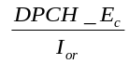 | dB | -16.0 | -9.0
Measured quality on DTCH | BLER | 0.01±30% | 0.01±30%

Power control in the downlink, initial convergence
This requirement verifies that DL power control works properly during the first seconds after DPCH connection is established

8.8.2.1 Minimum requirements
For the parameters specified in Table 8.31 the downlink DPCH_Ec/Ior power measured values, which are averaged over [50 ms], shall be within the range specified in Table 8.32 more than 90% of the time. T1 equals to [500 ms] and it starts [10 ms] after the DPDCH connection is initiated. T2 equals to [500 ms] and it starts when T1 has expired. Power control is ON during the test.
Table 8.31: Test parameters for downlink power control
Parameter | Unit | Test 1 | Test 2 | Test 3 | Test 4
Target quality value on DTCH | BLER | 0.01 | 0.01 | 0.1 | 0.1
Initial DPCH_Ec/Ior | dB | -5.9 | -25.9 | -2.1 | -22.1
Information Data Rate | kbps | 12.2 | 12.2 | 64 | 64
 | dB | -1
 | dBm/3.84 MHz | -60
Propagation condition |  | [Static]
Maximum_DL_Power | dB | 7
Minimum_DL_Power | dB | -18
Limited_Power_Raise_Used | - | "Not used"

Table 8.32: Requirements in downlink power control
Parameter | Unit | Test 1 and Test 2 | Test 3 and Test 4
during T1 | dB | [-18.9 ≤ DPCH_Ec/Ior ≤ -11.9] | [-15.1 ≤ DPCH_Ec/Ior ≤ -8.1]
during T2 | dB | [-18.9 ≤ DPCH_Ec/Ior ≤ -14.9] | [-15.1 ≤ DPCH_Ec/Ior ≤ -11.1]

8.8.3 Power control in downlink, wind up effects

8.8.3.1 Minimum requirements
This test is run in three stages where stage 1 is for convergence of the power control loop, in stage two the maximum downlink power for the dedicated channel is limited not to be higher than the parameter specified in Table 8.33. All parameters used in the three stages are specified in Table 8.33. The downlink power measured values, which are averaged over one slot, during stage 3 shall be lower than the value specified in Table 8.34 more than 90% of the time.
Power control of the UE is ON during the test.
Table 8.33: Test parameter for downlink power control, wind-up effects
Parameter | Unit | Test 1
Parameter | Unit | Stage 1 | Stage 2 | Stage 3
Time in each stage | s | >15 | 5 | 0.5
 | dB | 5
 | dBm/3.84 MHz | -60
Information Data Rate | kbps | 12.2
Quality target on DTCH | BLER | 0.01
Propagation condition |  | Case 4
Maximum_DL_Power | dB | 7 | -6.2 | 7
Minimum_DL_Power | dB | -18
Limited_Power_Raise_Used | - | “Not used”

Table 8.34: Requirements in downlink power control, wind-up effects
Parameter | Unit | Test 1, stage 3
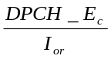 | dB | [-13.3]

8.9 Downlink compressed mode
Downlink compressed mode is used to create gaps in the downlink transmission, to allow the UE to make measurements on other frequencies.

8.9.1 Single link performance
The receiver single link performance of the Dedicated Traffic Channel (DCH) in compressed mode is determined by the Block Error Ratio (BLER) and transmitted DPCH_Ec/Ior power in the downlink.
The compressed mode parameters are given in clause A.5. Tests 1 and 2 are using Set 1 compressed mode pattern parameters from Table A.21 in clause A.5 while tests 3 and 4 are using Set 2 compressed mode patterns from the same table.

8.9.1.1 Minimum requirements
For the parameters specified in Table 8.35 the downlink power measured values, which are averaged over one slot, shall be below the specified value in Table 8.36 more than 90% of the time. The measured quality on DTCH shall be as required in Table 8.36.
Downlink power control is ON during the test. Uplink TPC commands shall be error free. System simulator shall increase the transmitted power during compressed frames by the same amount that UE is expected to increase its SIR target during those frames.
Table 8.35: Test parameter for downlink compressed mode
Parameter | Unit | Test 1 | Test 2 | Test 3 | Test 4
Delta SIR1 | dB | 0 | 3 | 0 | 3
Delta SIR after1 | dB | 0 | 3 | 0 | 3
Delta SIR2 | dB | 0 | 0 | 0 | 0
Delta SIR after2 | dB | 0 | 0 | 0 | 0
 | dB | 9
 | dBm/3.84 MHz | -60
Information Data Rate | kbps | 12.2
Propagation condition |  | Case 2
Target quality value on DTCH | BLER | 0.01
Maximum_DL_Power | dB | 7
Minimum_DL_Power | dB | -18
Limited_Power_Raise_Used | - | "Not used"

Table 8.36: Requirements in downlink compressed mode
Parameter | Unit | Test 1 | Test 2 | Test 3 | Test 4
 | dB | -14.8 | No requirements | -15.4 | No requirements
Measured quality of compressed and recovery frames | BLER | No requirements | <0.001 | No requirements | <0.001
Measured quality on DTCH | BLER | 0.01 ± 30 %

8.10 Blind transport format detection
Performance of Blind transport format detection is determined by the Block Error Ratio (BLER) values and by the measured average transmitted DPCH_Ec/Ior value.

8.10.1 Minimum requirement
For the parameters specified in Table 8.37 the average downlink power shall be below the specified value for the BLER shown in Table 8.38.

Table 8.37: Test parameters for Blind transport format detection
Parameter | Unit | Test 1 | Test 2 | Test 3 |  | Test 4 | Test 5 | Test 6
 | dB | -1 |  |  | -3
 | dBm/3.84 MHz | -60
Information Data Rate | kbps | 12.2 (rate 1) | 7.95 (rate 2) | 1.95 (rate 3) |  | 12.2 (rate 1) | 7.95 (rate 2) | 1.95 (rate 3)
propagation condition | - | static |  |  |  | multi-path fading case 3
TFCI | - | off

Table 8.38: The Requirements for DCH reception in Blind transport format detection
Test Number |  | BLER | FDR
1 | [-17.7dB] | 10⁻² | 10⁻⁴
2 | [-17.8 dB] | 10⁻² | 10⁻⁴
3 | [-18.4 dB] | 10⁻² | 10⁻⁴
4 | [-13.0 dB] | 10⁻² | 10⁻⁴
5 | [-13.2 dB] | 10⁻² | 10⁻⁴
6 | [-13.8 dB] | 10⁻² | 10⁻⁴
* The value of DPCH_Ec/Ior, Ioc, and Ior/Ioc are defined in case of DPCH is transmitted
NOTE: In this test, 9 different Transport Format Combinations (Table 8.39) are sent during the call set up procedure, so that the UE has to detect the correct transport format from these 9 candidates.

Table 8.39: Transport format combinations informed during the call set up procedure in the test
 | 1 | 2 | 3 | 4 | 5 | 6 | 7 | 8 | 9
DTCH | 12.2k | 10.2k | 7.95k | 7.4k | 6.7k | 5.9k | 5.15k | 4.75k | 1.95k
DCCH |  |  |  |  | 2.4k

Annex A (normative):
Measurement channels

A.1 General
The measurement channels in this annex are defined to derive the requirements in clauses 6, 7 and 8. The measurement channels represent example configuration of radio access bearers for different data rates.
The measurement channel for 12.2 kbps shall be supported by any UE both in up- and downlink. Support for other measurement channels is depending on the UE Radio Access capabilities.

A.2 UL reference measurement channel

A.2.1 UL reference measurement channel (12.2 kbps)
The parameters for the 12.2 kbps UL reference measurement channel are specified in Table A.1 and Table A.2. The channel coding for information is shown in figure A.1.
Table A.1: UL reference measurement channel physical parameters (12.2 kbps)
Parameter | Unit | Level
Information bit rate | kbps | 12.2
DPDCH | kbps | 60
DPCCH | kbps | 15
DPCCH Slot Format #i | - | 0
DPCCH/DPDCH power ratio | dB | -5.46
TFCI | - | On
Repetition | % | 23
NOTE: Slot Format #2 is used for closed loop tests in subclause 8.6.2.

Table A.2: UL reference measurement channel, transport channel parameters (12.2 kbps)
Parameters | DTCH | DCCH
Transport Channel Number | 1 | 2
Transport Block Size | 244 | 100
Transport Block Set Size | 244 | 100
Transmission Time Interval | 20 ms | 40 ms
Type of Error Protection | Convolution Coding | Convolution Coding
Coding Rate | 1/3 | 1/3
Rate Matching attribute | 256 | 256
Size of CRC | 16 | 12

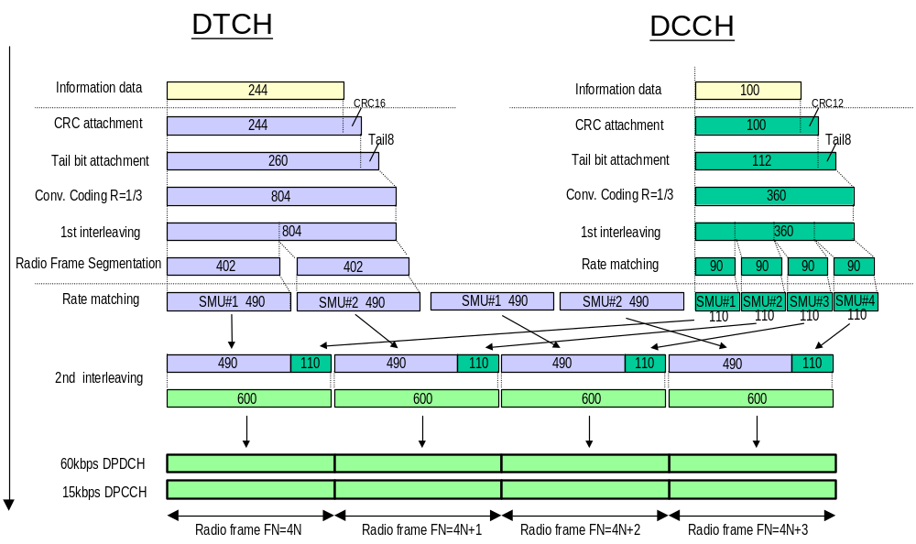
Figure A.1 (Informative): Channel coding of UL reference measurement channel (12.2 kbps)

A.2.2 UL reference measurement channel (64 kbps)
The parameters for the 64 kbps UL reference measurement channel are specified in Table A.3 and Table A.4. The channel coding for information is shown in figure A.2. This measurement channel is not currently used in TS 25.101 but can be used for future requirements.
Table A.3: UL reference measurement channel (64 kbps)
Parameter | Unit | Level
Information bit rate | kbps | 64
DPDCH | kbps | 240
DPCCH | kbps | 15
DPCCH Slot Format #i | - | 0
DPCCH/DPDCH power ratio | dB | -9.54
TFCI | - | On
Repetition | % | 18

Table A.4: UL reference measurement channel, transport channel parameters (64 kbps)
Parameter | DTCH | DCCH
Transport Channel Number | 1 | 2
Transport Block Size | 1280 | 100
Transport Block Set Size | 1280 | 100
Transmission Time Interval | 20 ms | 40 ms
Type of Error Protection | Turbo Coding | Convolution Coding
Coding Rate | 1/3 | 1/3
Rate Matching attribute | 256 | 256
Size of CRC | 16 | 12

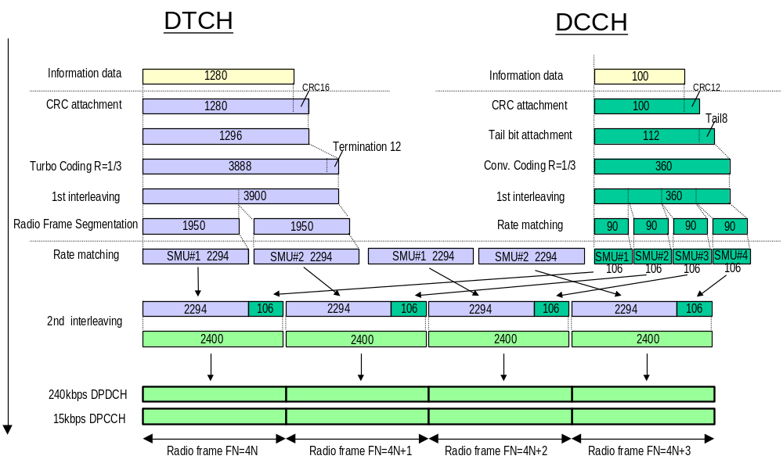
Figure A.2 (Informative): Channel coding of UL reference measurement channel (64 kbps)

A.2.3 UL reference measurement channel (144 kbps)
The parameters for the 144 kbps UL reference measurement channel are specified in Table A.5 and Table A.6. The channel coding for information is shown in Figure A.3. This measurement channel is not currently used in the present document but can be used for future requirements.
Table A.5: UL reference measurement channel (144 kbps)
Parameter | Unit | Level
Information bit rate | kbps | 144
DPDCH | kbps | 480
DPCCH | kbps | 15
DPCCH Slot Format #i | - | 0
DPCCH/DPDCH power ratio | dB | -11.48
TFCI | - | On
Repetition | % | 8

Table A.6: UL reference measurement channel, transport channel parameters (144kbps)
Parameters | DTCH | DCCH
Transport Channel Number | 1 | 2
Transport Block Size | 2880 | 100
Transport Block Set Size | 2880 | 100
Transmission Time Interval | 20 ms | 40 ms
Type of Error Protection | Turbo Coding | Convolution Coding
Coding Rate | 1/3 | 1/3
Rate Matching attribute | 256 | 256
Size of CRC | 16 | 12

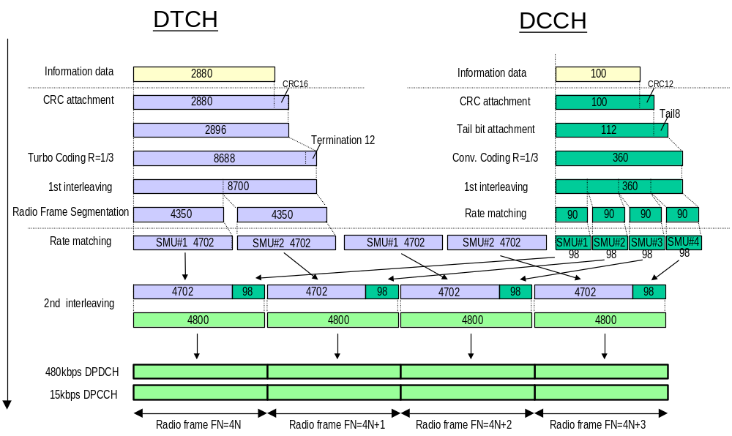
Figure A.3 (Informative): Channel coding of UL reference measurement channel (144 kbps)

A.2.4 UL reference measurement channel (384 kbps)
The parameters for the 384 kbps UL reference measurement channel are specified in Table A.7 and Table A.8. The channel coding for information is shown in Figure A.4. This measurement channel is not currently used in TS 25.101 but can be used for future requirements.
Table A.7: UL reference measurement channel (384 kbps)
Parameter | Unit | Level
Information bit rate | kbps | 384
DPDCH | kbps | 960
DPCCH | kbps | 15
DPCCH/DPDCH power ratio | dB | -11.48
TFCI | - | On
Puncturing | % | 18

Table A.8: UL reference measurement channel, transport channel parameters (384 kbps)
Parameter | DTCH | DCCH
Transport Channel Number | 1 | 2
Transport Block Size | 3840 | 100
Transport Block Set Size | 3840 | 100
Transmission Time Interval | 10 ms | 40 ms
Type of Error Protection | Turbo Coding | Convolution Coding
Coding Rate | 1/3 | 1/3
Rate Matching attribute | 256 | 256
Size of CRC | 16 | 12

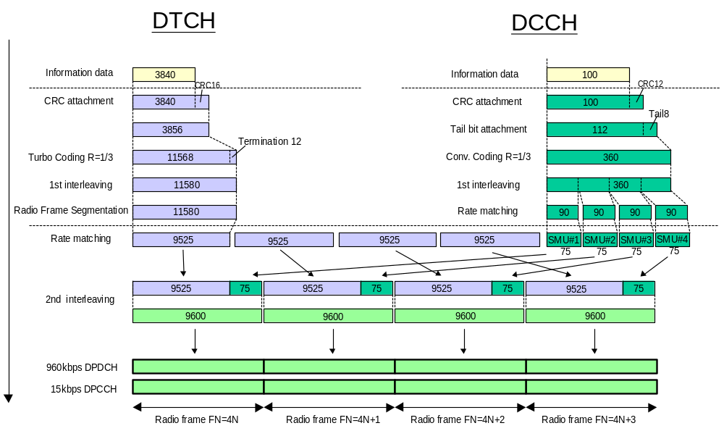
Figure A.4 (Informative): Channel coding of UL reference measurement channel (384 kbps)

A.2.5 UL reference measurement channel (768 kbps)
The parameters for the UL measurement channel for 768 kbps are specified in Table A.9 and Table A.10.
Table A.9: UL reference measurement channel, physical parameters (768 kbps)
Parameter | Unit | Level
Information bit rate | kbps | 2*384
DPDCH₁ | kbps | 960
DPDCH₂ | kbps | 960
DPCCH | kbps | 15
DPCCH/DPDCH power ratio | dB | -11.48
TFCI | - | On
Puncturing | % | 18

Table A.10: UL reference measurement channel, transport channel parameters (768 kbps)
Parameter | DTCH | DCCH
Transport Channel Number | 1 | 2
Transport Block Size | 3840 | 100
Transport Block Set Size | 7680 | 100
Transmission Time Interval | 10 ms | 40 ms
Type of Error Protection | Turbo Coding | Convolution Coding
Coding Rate | 1/3 | 1/3
Rate Matching attribute | 256 | 256
Size of CRC | 16 | 12

A.3 DL reference measurement channel

A.3.1 DL reference measurement channel (12.2 kbps)
The parameters for the 12.2 Kbps DL reference measurement channel are specified in Table A.11 and Table A.12. The channel coding is shown for information in figure A.5.
Table A.11: DL reference measurement channel physical parameters (12.2 kbps)
Parameter | Unit | Level
Information bit rate | kbps | 12.2
DPCH | ksps | 30
Slot Format #i | - | 11
TFCI | - | On
Power offsets PO1, PO2 and PO3 | dB | 0
Puncturing | % | 14.7

Table A.12: DL reference measurement channel, transport channel parameters (12.2 kbps)
Parameter | DTCH | DCCH
Transport Channel Number | 1 | 2
Transport Block Size | 244 | 100
Transport Block Set Size | 244 | 100
Transmission Time Interval | 20 ms | 40 ms
Type of Error Protection | Convolution Coding | Convolution Coding
Coding Rate | 1/3 | 1/3
Rate Matching attribute | 256 | 256
Size of CRC | 16 | 12
Position of TrCH in radio frame | fixed | fixed

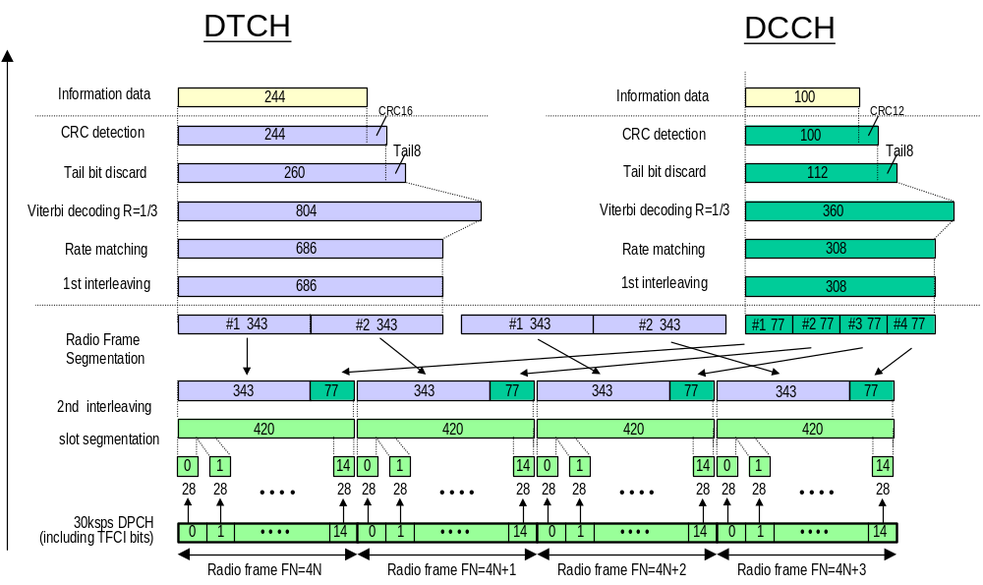
Figure A.5 (Informative): Channel coding of DL reference measurement channel (12.2 kbps)

A.3.2 DL reference measurement channel (64 kbps)
The parameters for the DL reference measurement channel for 64 kbps are specified in Table A.13 and Table A.14. The channel coding is shown for information in Figure A.6.
Table A.13: DL reference measurement channel physical parameters (64 kbps)
Parameter | Unit | Level
Information bit rate | kbps | 64
DPCH | ksps | 120
Slot Format #i | - | 13
TFCI | - | On
Power offsets PO1, PO2 and PO3 | dB | 0
Repetition | % | 2.9

Table A.14: DL reference measurement channel, transport channel parameters (64 kbps)
Parameter | DTCH | DCCH
Transport Channel Number | 1 | 2
Transport Block Size | 1280 | 100
Transport Block Set Size | 1280 | 100
Transmission Time Interval | 20 ms | 40 ms
Type of Error Protection | Turbo Coding | Convolution Coding
Coding Rate | 1/3 | 1/3
Rate Matching attribute | 256 | 256
Size of CRC | 16 | 12
Position of TrCH in radio frame | fixed | fixed

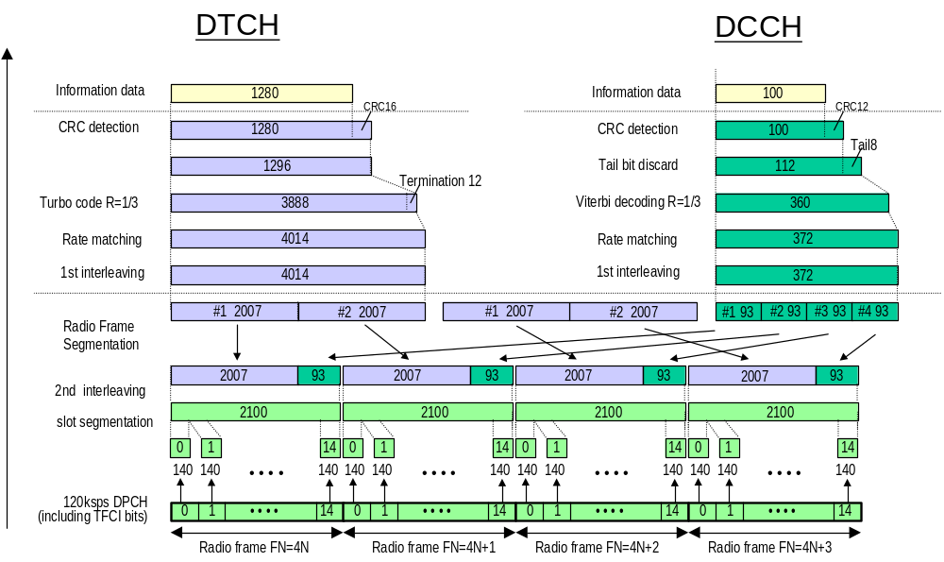
Figure A.6 (Informative): Channel coding of DL reference measurement channel (64 kbps)

A.3.3 DL reference measurement channel (144 kbps)
The parameters for the DL measurement channel for 144 kbps are specified in Table A.15 and Table A.16. The channel coding is shown for information in Figure A.7.
Table A.15: DL reference measurement channel physical parameters (144 kbps)
Parameter | Unit | Level
Information bit rate | kbps | 144
DPCH | ksps | 240
Slot Format #i | - | 14
TFCI | - | On
Power offsets PO1, PO2 and PO3 | dB | 0
Puncturing | % | 2.7

Table A.16: DL reference measurement channel, transport channel parameters (144 kbps)
Parameter | DTCH | DCCH
Transport Channel Number | 1 | 2
Transport Block Size | 2880 | 100
Transport Block Set Size | 2880 | 100
Transmission Time Interval | 20 ms | 40 ms
Type of Error Protection | Turbo Coding | Convolution Coding
Coding Rate | 1/3 | 1/3
Rate Matching attribute | 256 | 256
Size of CRC | 16 | 12
Position of TrCH in radio frame | fixed | fixed

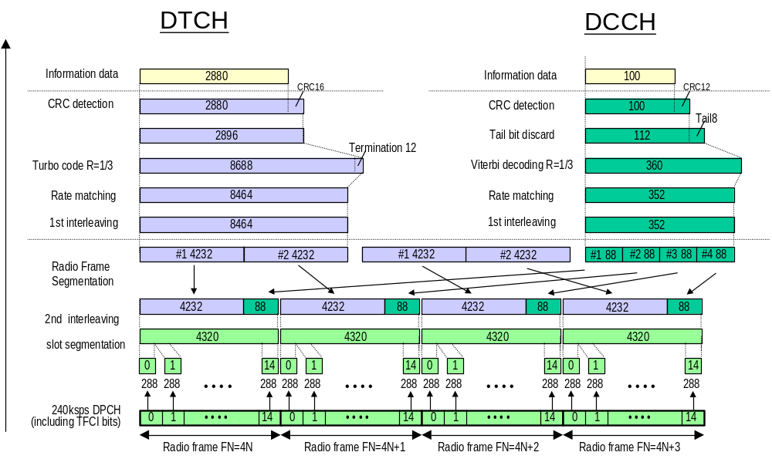
Figure A.7 (Informative): Channel coding of DL reference measurement channel (144 kbps)

A.3.4 DL reference measurement channel (384 kbps)
The parameters for the DL measurement channel for 384 kbps are specified in Table A.17 and Table A.18. The channel coding is shown for information in Figure A.8
Table A.17: DL reference measurement channel, physical parameters (384 kbps)
Parameter | Unit | Level
Information bit rate | kbps | 384
DPCH | ksps | 480
Slot Format # i | - | 15
TFCI |  | On
Power offsets PO1, PO2 and PO3 | dB | 0
Puncturing | % | 22

Table A.18: DL reference measurement channel, transport channel parameters (384 kbps)
Parameter | DTCH | DCCH
Transport Channel Number | 1 | 2
Transport Block Size | 3840 | 100
Transport Block Set Size | 3840 | 100
Transmission Time Interval | 10 ms | 40 ms
Type of Error Protection | Turbo Coding | Convolution Coding
Coding Rate | 1/3 | 1/3
Rate Matching attribute | 256 | 256
Size of CRC | 16 | 12
Position of TrCH in radio frame | fixed | Fixed
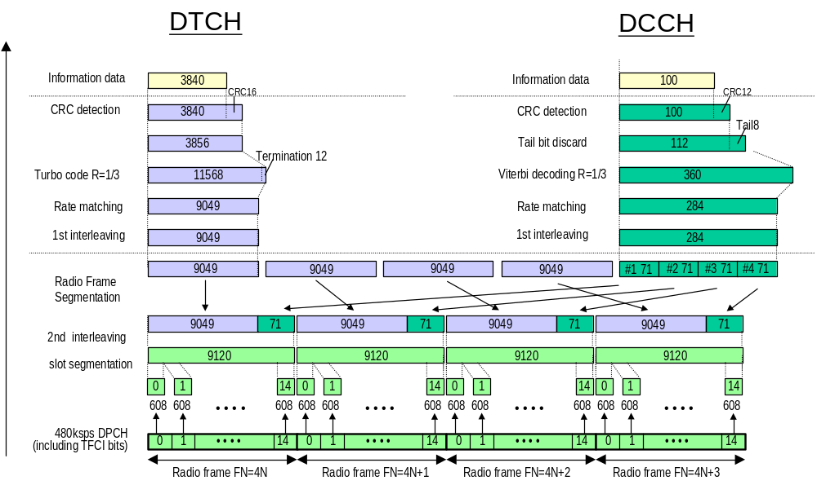

Figure A.8 (Informative): Channel coding of DL reference measurement channel (384 kbps)

A.4 DL reference measurement channel for BTFD performance requirements
The parameters for DL reference measurement channel for BTFD are specified in Table A.19 and Table A.20. The channel coding for information is shown in figures A.9, A.10, and A11.
Table A.19: DL reference measurement channel physical parameters for BTFD
Parameter | Unit | Rate 1 | Rate 2 | Rate 3
Information bit rate | kbps | 12.2 | 7.95 | 1.95
DPCH | ksps | 30
Slot Format # i | - | 8
TFCI | - | Off
Power offsets PO1, PO2 and PO3 | dB | 0
Repetition | % | 5

Table A.20: DL reference measurement channel, transport channel parameters for BTFD
Parameter | DTCH |  |  |  | DCCH
Parameter | Rate 1 | Rate 2 | Rate 3 |  | DCCH
Transport Channel Number | 1 |  |  | 2
Transport Block Size | 244 | 159 | 39 |  | 100
Transport Block Set Size | 244 | 159 | 39 |  | 100
Transmission Time Interval | 20 ms |  |  | 40 ms
Type of Error Protection | Convolution Coding |  |  | Convolution Coding
Coding Rate | 1/3 |  |  | 1/3
Rate Matching attribute | 256 |  |  | 256
Size of CRC | 12 |  |  | 12
Position of TrCH in radio frame | fixed |  |  | fixed

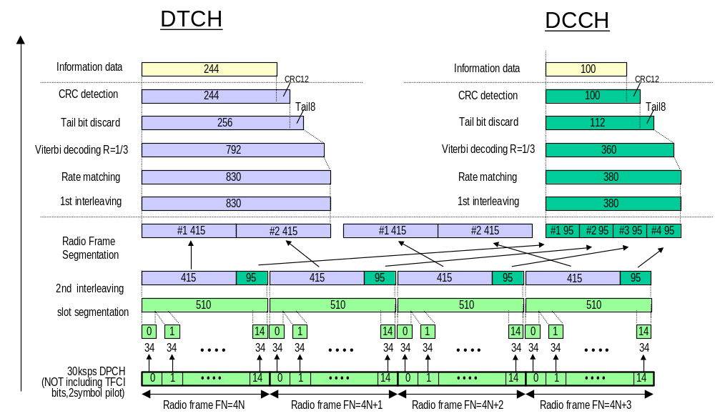

Figure A.9 (Informative): Channel coding of DL reference measurement channel for BTFD (Rate 1)

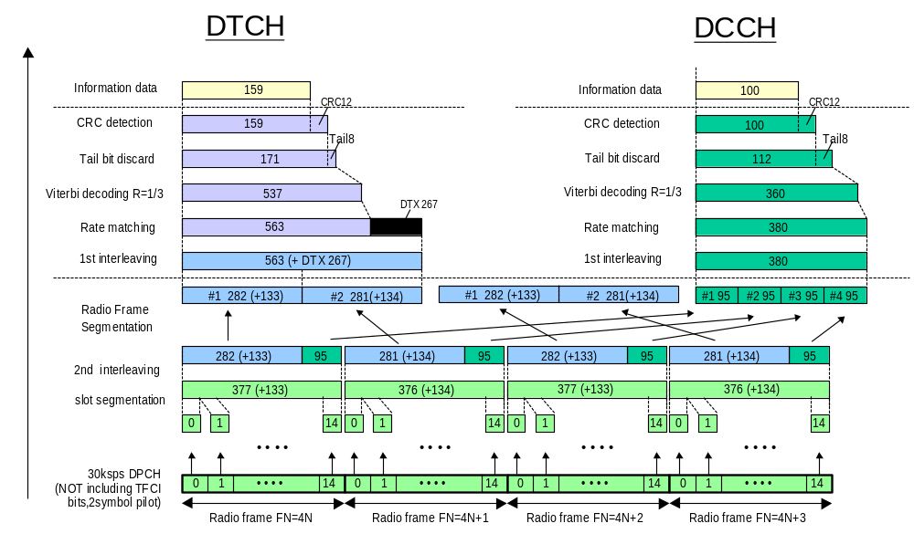

Figure A.10 (Informative): Channel coding of DL reference measurement channel for BTFD (Rate 2)

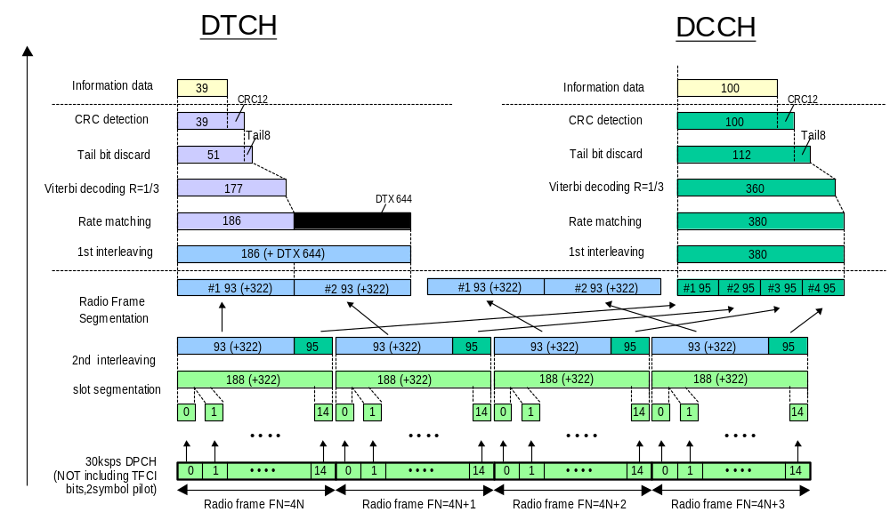

Figure A.11 (Informative): Channel coding of DL reference measurement channel for BTFD (Rate 3)

A.5 DL reference compressed mode parameters
Parameters described in Table A.21 are used in some test specified in TS 25.101 while parameters described in Table A.22 are used in some tests specified in TS 25.133.
Set 1 parameters in Table A.21 are applicable when compressed mode by spreading factor reduction is used in downlink. Set 2 parameters in Table A.21 are applicable when compressed mode by puncturing is used in downlink.

Table A.21: Compressed mode reference pattern 1 parameters
Parameter | Set 1 | Set 2 | Note
TGSN (Transmission Gap Starting Slot Number) | 11 | 11
TGL1 (Transmission Gap Length 1) | 7 | 7
TGL2 (Transmission Gap Length 2) | - | - | Only one gap in use.
TGD (Transmission Gap Distance) | 0 | 0 | Only one gap in use.
TGPL1 (Transmission Gap Pattern Length) | 2 | 4
TGPL2 (Transmission Gap Pattern Length) | - | - | Only one pattern in use.
TGPRC (Transmission Gap Pattern Repetition Count) | NA | NA | Defined by higher layers
TGCFN (Transmission Gap Connection Frame Number): | NA | NA | Defined by higher layers
UL/DL compressed mode selection | DL & UL | DL & UL | 2 configurations possible DL &UL / DL
UL compressed mode method | SF/2 | SF/2
DL compressed mode method | SF/2 | Puncturing
Downlink frame type and Slot format | 11B | 11A
Scrambling code change | No | No
RPP ( Recovery period power control mode) | 0 | 0
ITP ( Initial transmission power control mode) | 0 | 0

Table A.22: Compressed mode reference pattern 2 parameters
Parameter | Set 1 | Set 2 | Note
TGSN (Transmission Gap Starting Slot Number) | 4 | 4
TGL1 (Transmission Gap Length 1) | 7 | 7
TGL2 (Transmission Gap Length 2) | - | - | Only one gap in use.
TGD (Transmission Gap Distance) | 0 | 0
TGPL1 (Transmission Gap Pattern Length) | 3 | 12
TGPL2 (Transmission Gap Pattern Length) | - | - | Only one pattern in use.
TGPRC (Transmission Gap Pattern Repetition Count) | NA | NA | Defined by higher layers
TGCFN (Transmission Gap Connection Frame Number): | NA | NA | Defined by higher layers
UL/DL compressed mode selection | DL & UL | DL & UL | 2 configurations possible. DL & UL / DL
UL compressed mode method | SF/2 | SF/2
DL compressed mode method | SF/2 | SF/2
Downlink frame type and Slot format | 11B | 11B
Scrambling code change | No | No
RPP (Recovery period power control mode) | 0 | 0
ITP (Initial transmission power control mode) | 0 | 0

Annex B (normative):
Propagation conditions

B.1 General

B.2 Propagation Conditions

B.2.1 Static propagation condition
The propagation for the static performance measurement is an Additive White Gaussian Noise (AWGN) environment. No fading and multi-paths exist for this propagation model.

B.2.2 Multi-path fading propagation conditions
Table B1 shows propagation conditions that are used for the performance measurements in multi-path fading environment. All taps have classical Doppler spectrum.

Table B.1: Propagation Conditions for Multi path Fading Environments
Case 1,  speed 3km/h |  | Case 2,  speed 3 km/h |  | Case 3,  speed 120 km/h |  | Case 4,  speed 3 km/h |  | * Case 5,  speed 50 km/h
Relative Delay [ns] | Average Power [dB] | Relative Delay [ns] | Average Power [dB] | Relative Delay [ns] | Average Power [dB] | Relative Delay [ns] | Average Power [dB] | Relative Delay [ns] | Average Power [dB]
0 | 0 | 0 | 0 | 0 | 0 | 0 | 0 | 0 | 0
976 | -10 | 976 | 0 | 260 | -3 | 976 | 0 | 976 | -10
 |  | 20000 | 0 | 521 | -6
 |  |  |  | 781 | -9

Note Case 5 is only used in TS25.133.

B.2.3 Moving propagation conditions
The dynamic propagation conditions for the test of the baseband performance are non fading channel models with two taps. The moving propagation condition has two tap, one static, Path0, and one moving, Path1. The time difference between the two paths is according Equation (B.1). The taps have equal strengths and equal phases.
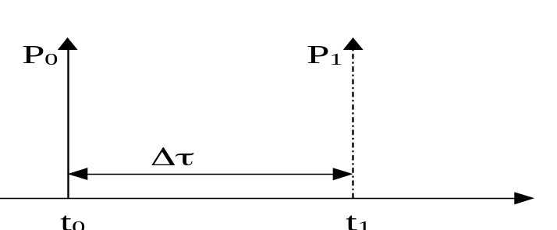

Figure B.1: The moving propagation conditions

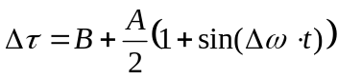
Equation B.1
The parameters in the equation are shown in.
A | 5 μs
B | 1 μs
Δω | 40*10⁻³ s⁻¹

B.2.4 Birth-Death propagation conditions
The dynamic propagation conditions for the test of the baseband performance is a non fading propagation channel with two taps. The moving propagation condition has two taps, Path1 and Path2 which alternate between 'birth' and 'death'. The positions the paths appear are randomly selected with an equal probability rate and is shown in Figure B.2.

P
1
P
2
P
1
[
us]

P
1
P
2
[
us]

P
2
P
1
[
us]
P
2

Figure B.2: Birth death propagation sequence
- Two paths, Path1 and Path2 are randomly selected from the group[-5,-4,-3,-2,-1,0,1,2,3,4,5] μs. The paths have equal magnitudes and equal phases.
- After 191 ms, Path1 vanishes and reappears immediately at a new location randomly selected from the group [-5,-4,-3,-2,-1,0,1,2,3,4,5] μs but excludes the point Path 2. The magnitudes and the phases of the tap coefficients of Path 1 and Path 2 shall remain unaltered.
- After an additional 191 ms, Path2 vanishes and reappears immediately at a new location randomly selected from the group [-5,-4,-3,-2,-1,0,1,2,3,4,5] μs but excludes the point Path 1. The magnitudes and the phases of the tap coefficients of Path 1 and Path 2 shall remain unaltered.
- The sequence in 2) and 3) is repeated.

Annex C (normative):
Downlink Physical Channels

C.1 General
This annex specifies the downlink physical channels that are needed for setting a connection and channels that are needed during a connection.

C.2 Connection Set-up
Table C.1 describes the downlink Physical Channels that are required for connection set up.
Table C.1. Downlink Physical Channels required
for connection set-up
Physical Channel
P-CPICH
P-CCPCH
SCH
S-CCPCH
PICH
AICH
DPCH

C.3 During connection
The following clauses, describes the downlink Physical Channels that are transmitted during a connection i.e., when measurements are done. For these measurements the offset between DPCH and SCH shall be zero chips at Node B meaning that SCH is overlapping with the first symbols in DPCH in the beginning of DPCH slot structure.

C.3.1 Measurement of Rx Characteristics
Table C.2 is applicable for measurements on the Receiver Characteristics (clause 7) with the exception of subclause 7.4 (Maximum input level).

Table C.2: Downlink Physical Channels transmitted during a connection
Physical Channel | Power
P-CPICH | P-CPICH_Ec / DPCH_Ec = 7 dB
P-CCPCH | P-CCPCH_Ec / DPCH_Ec = 5 dB
SCH | SCH_Ec / DPCH_Ec = 5 dB
PICH | PICH_Ec / DPCH_Ec = 2 dB
DPCH | Test dependent power

C.3.2 Measurement of Performance requirements
Table C.3 is applicable for measurements on the Performance requirements (clause 8), including subclause 7.4 (Maximum input level).
Table C.3: Downlink Physical Channels transmitted during a connection1
Physical Channel | Power | NOTE
P-CPICH | P-CPICH_Ec/Ior = -10 dB | Use of P-CPICH or S-CPICH as phase reference is specified for each requirement and is also set by higher layer signalling.
S-CPICH | S-CPICH_Ec/Ior = -10 dB | When S-CPICH is the phase reference in a test condition, the phase of S-CPICH shall be 180 degrees offset from the phase of P-CPICH. When S-CPICH is not the phase reference, it is not transmitted.
P-CCPCH | P-CCPCH_Ec/Ior = -12 dB
SCH | SCH_Ec/Ior = -12 dB | This power shall be divided equally between Primary and Secondary Synchronous channels
PICH | PICH_Ec/Ior = -15 dB
DPCH | Test dependent power | When S-CPICH is the phase reference in a test condition, the phase of DPCH shall be 180 degrees offset from the phase of P-CPICH.
OCNS | Necessary power so that total transmit power spectral density of Node B (Ior) adds to one | OCNS interference consists of 16 dedicated data channels. The channelization codes, level settings and timing offsets for data channels are chosen as specified for the 16 DPCH channels of Test Model 1 in TS 25.141 Table 6.2. All dedicated channels user data is uncorrelated to each other and the measurement channel during the BER/BLER measurement period.

C.3.3 Connection with open-loop transmit diversity mode
Table C.4 is applicable for measurements for subclause 8.6.1(Demodulation of DCH in open loop transmit diversity mode)

Table C.4: Downlink Physical Channels transmitted during a connection1
Physical Channel | Power | NOTE
P-CPICH (antenna 1) | P-CPICH_Ec1/Ior = -13 dB | 1. Total P-CPICH_Ec/Ior = -10 dB
P-CPICH (antenna 2) | P-CPICH_Ec2/Ior = -13 dB | 1. Total P-CPICH_Ec/Ior = -10 dB
P-CCPCH (antenna 1) | P-CCPCH_Ec1/Ior = -15 dB | 1. STTD applied  2. Total P-CCPCH_Ec/Ior = -12 dB
P-CCPCH (antenna 2) | P-CCPCH_Ec2/Ior = -15 dB | 1. STTD applied  2. Total P-CCPCH_Ec/Ior = -12 dB
SCH (antenna 1 / 2) | SCH_Ec/Ior = -12 dB | 1. TSTD applied.  2. This power shall be divided equally between Primary and Secondary Synchronous channels
PICH (antenna 1) | PICH_Ec1/Ior = -18 dB | 1. STTD applied  2. Total PICH_Ec/Ior = -15 dB
PICH (antenna 2) | PICH_Ec2/Ior = -18 dB | 1. STTD applied  2. Total PICH_Ec/Ior = -15 dB
DPCH | Test dependent power | 1. STTD applied  2. Total power from both antennas
OCNS | Necessary power so that total transmit power spectral density of Node B (Ior) adds to one | - This power shall be divided equally between antennas  - OCNS interference consists of 16 dedicated data channels. The channelization codes, level settings and timing offsets for data channels are chosen as specified for the 16 DPCH channels of Test Model 1 in TS 25.141 Table 6.2. All dedicated channels user data is uncorrelated to each other and the measurement channel during the BER/BLER measurement period.

C.3.4 Connection with closed loop transmit diversity mode
Table C.5 is applicable for measurements for subclause 8.6.2 (Demodulation of DCH in closed loop transmit diversity mode).

Table C.5: Downlink Physical Channels transmitted during a connection1
Physical Channel | Power | NOTE
P-CPICH (antenna 1) | P-CPICH_Ec1/Ior = -13 dB | 1. Total P-CPICH_Ec/Ior = -10 dB
P-CPICH (antenna 2) | P-CPICH_Ec2/Ior = -13 dB | 1. Total P-CPICH_Ec/Ior = -10 dB
P-CCPCH (antenna 1) | P-CCPCH_Ec1/Ior = -15 dB | 1. STTD applied
P-CCPCH (antenna 2) | P-CCPCH_Ec2/Ior = -15 dB | - STTD applied,  - total P-CCPCH_Ec/Ior = -12 dB
SCH (antenna 1 / 2) | SCH_Ec/Ior = -12 dB | 1. TSTD applied
PICH (antenna 1) | PICH_Ec1/Ior = -18 dB | 1. STTD applied  2. STTD applied, total PICH_Ec/Ior = -15 dB
PICH (antenna 2) | PICH_Ec2/Ior = -18 dB | 1. STTD applied  2. STTD applied, total PICH_Ec/Ior = -15 dB
DPCH | Test dependent power | 1. Total power from both antennas
OCNS | Necessary power so that total transmit power spectral density of Node B (Ior) adds to one | - This power shall be divided equally between antennas  - OCNS interference consists of 16 dedicated data channels. The channelization codes, level settings and timing offsets for data channels are chosen as specified for the 16 DPCH channels of Test Model 1 in TS 25.141 Table 6.2. All dedicated channels user data is uncorrelated to each other and the measurement channel during the BER/BLER measurement period.

Annex D (normative):
Environmental conditions

D.1 General
This normative annex specifies the environmental requirements of the UE. Within these limits the requirements of the present documents shall be fulfilled.

D.2 Environmental requirements
The requirements in this clause apply to all types of UE(s).

D.2.1 Temperature
The UE shall fulfil all the requirements in the full temperature range of:

Table D.1
+15°C to +35°C | for normal conditions (with relative humidity of 25 % to 75 %)
-10°C to +55°C | for extreme conditions (see IEC publications 68-2-1 and 68-2-2)

Outside this temperature range the UE, if powered on, shall not make ineffective use of the radio frequency spectrum. In no case shall the UE exceed the transmitted levels as defined in TS 25.101 for extreme operation.

D.2.2 Voltage
The UE shall fulfil all the requirements in the full voltage range, i.e. the voltage range between the extreme voltages.
The manufacturer shall declare the lower and higher extreme voltages and the approximate shutdown voltage. For the equipment that can be operated from one or more of the power sources listed below, the lower extreme voltage shall not be higher, and the higher extreme voltage shall not be lower than that specified below.

Table D.2
Power source | Lower extreme  voltage | Higher extreme  voltage | Normal conditions  voltage
AC mains | 0,9 * nominal | 1,1 * nominal | nominal
Regulated lead acid battery | 0,9 * nominal | 1,3 * nominal | 1,1 * nominal
Non regulated batteries:  Leclanché / lithium  Mercury/nickel & cadmium | 0,85 * nominal  0,90 * nominal | Nominal  Nominal | Nominal  Nominal

Outside this voltage range the UE if powered on, shall not make ineffective use of the radio frequency spectrum. In no case shall the UE exceed the transmitted levels as defined in TS 25.101 for extreme operation. In particular, the UE shall inhibit all RF transmissions when the power supply voltage is below the manufacturer declared shutdown voltage.

D.2.3 Vibration
The UE shall fulfil all the requirements when vibrated at the following frequency/amplitudes.

Table D.3
Frequency | ASD (Acceleration Spectral Density) random vibration
5 Hz to 20 Hz | 0,96 m2/s3
20 Hz to 500 Hz | 0,96 m2/s3 at 20 Hz, thereafter –3 dB/Octave

Outside the specified frequency range the UE, if powered on, shall not make ineffective use of the radio frequency spectrum. In no case shall the UE exceed the transmitted levels as defined in TS 25.101 for extreme operation

Annex F (informative):
UE capabilities (FDD)
This annex provides the UE capabilities related to TS 25.101.

NOTES:
This annex shall be aligned with TR25.926, UE Radio Access Capabilities regarding FDD RF parameters. These RF UE Radio Access capabilities represent options in the UE, that require signalling to the network.
In addition there are options in the UE that do not require any signalling. They are designated as UE baseline capabilities, according to TR 21.904, Terminal Capability Requirements.
Table F.1 provides the list of UE radio access capability parameters and possible values for TS 25.101.

Table F.1: RF UE Radio Access Capabilities
Table F.1: RF UE Radio Access Capabilities | UE radio access capability parameter | Value range
FDD RF parameters | UE power class  (TS 25.101, subclause 6.2.1) | 3, 4
FDD RF parameters | Tx/Rx frequency separation for frequency band a)  (TS 25.101, subclause 5.3)  Not applicable if UE is not operating in frequency band a) | 190 MHz,  174.8-205.2 MHz,  134.8-245.2 MHz

Table F.2 provides the UE baseline implementation capabilities for TS 25.101.

Table F.2: UE RF Baseline Implementation Capabilities
UE implementation capability | Value range
Radio frequency bands  (25.101 subclause 5.2) | a),  b),  a+b)

Annex G (informative):
Change history
Inclusion of CRs approved by TSG-RAN#6.
Doc-1st-Level | Spec | CR | R | Phase | Subject | Cat | Curr | New
RP-99772 | 25.101 | 001 | 2 | R99 | Correction of UE Measurement Channels Rev.2 | F | 3.0.0 | 3.1.0
RP-99772 | 25.101 | 003 |  | R99 | Modifications for Receiver Characteristics | F | 3.0.0 | 3.1.0
RP-99772 | 25.101 | 004 |  | R99 | Corrections to Tx Diversity testing assumptions | F | 3.0.0 | 3.1.0
RP-99771 | 25.101 | 005 |  | R99 | UE DL performance requirements | D | 3.0.0 | 3.1.0
RP-99772 | 25.101 | 006 | 1 | R99 | Corrections to Annex C Down link Physical Channels | F | 3.0.0 | 3.1.0
RP-99772 | 25.101 | 007 |  | R99 | Proposal for ACLR/ACS specifications for class 3 | F | 3.0.0 | 3.1.0
RP-99773 | 25.101 | 008 |  | R99 | Addition of propagation condition to inner and outer loop PC tests in downlink | B | 3.0.0 | 3.1.0
RP-99772 | 25.101 | 009 |  | R99 | Clarification of Uplink inner loop power control requirements | C | 3.0.0 | 3.1.0
RP-99773 | 25.101 | 010 |  | R99 | Modifications to demodulation test parameters and requirements in inter-cell soft handover | B | 3.0.0 | 3.1.0
RP-99772 | 25.101 | 011 |  | R99 | Power setting of DPCH | C | 3.0.0 | 3.1.0
RP-99771 | 25.101 | 012 |  | R99 | Editorial changes to 25.101v3.0.0 | D | 3.0.0 | 3.1.0
RP-99826 | 25.101 | 013 |  | R99 | Update of UE RF capabilities | F | 3.0.0 | 3.1.0
RP-99772 | 25.101 | 014 |  | R99 | Update of ITU Region 2 Specific Specifications and proposed universal channel numbering | C | 3.0.0 | 3.1.0
RP-99772 | 25.101 | 015 |  | R99 | Performance requirements for demodulation of DCH in Site Selection Diversity Transmission mode for Subclause 8.6.3 of 25.101v3.0.0 | F | 3.0.0 | 3.1.0
RP-99830 | 25.101 | 016 | 1 | R99 | Change of propagation conditions | F | 3.0.0 | 3.1.0
RP-99772 | 25.101 | 017 |  | R99 | CR for minimum requirements for UE power class 1 and 2 in 25.101 | F | 3.0.0 | 3.1.0
RP-99772 | 25.101 | 018 |  | R99 | Downlink Inner loop power control | C | 3.0.0 | 3.1.0
RP-99773 | 25.101 | 019 |  | R99 | Performance requirements in downlink compressed mode | B | 3.0.0 | 3.1.0

Inclusion of CRs approved by TSG-RAN#7.
Doc-1st-Level | Spec | CR | R | Phase | Subject | Cat | Curr | New
RP-000015 | 25.101 | 020 |  | R99 | Clarifications to measurement channels | F | 3.1.0 | 3.2.0
RP-000015 | 25.101 | 021 |  | R99 | Power measurement definitions for wanted signal (in-channel signal) | D | 3.1.0 | 3.2.0
RP-000015 | 25.101 | 022 |  | R99 | Change of propagation conditions for Case 2 | F | 3.1.0 | 3.2.0
RP-000015 | 25.101 | 023 |  | R99 | Editorial corrections | D | 3.1.0 | 3.2.0
RP-000015 | 25.101 | 024 |  | R99 | Birth-Death tap delays | F | 3.1.0 | 3.2.0
RP-000015 | 25.101 | 025 |  | R99 | Out-of-synchronization handling of the UE | C | 3.1.0 | 3.2.0
RP-000015 | 25.101 | 026 |  | R99 | UE Modulation performance requirements | F | 3.1.0 | 3.2.0
RP-000015 | 25.101 | 027 |  | R99 | Measurement channel for UE PCDE test | F | 3.1.0 | 3.2.0
RP-000015 | 25.101 | 028 |  | R99 | CR for performance requirement of BTFD | F | 3.1.0 | 3.2.0
RP-000015 | 25.101 | 029 |  | R99 | CPCH | B | 3.1.0 | 3.2.0
RP-000015 | 25.101 | 030 |  | R99 | Clarification of ACLR | D | 3.1.0 | 3.2.0
RP-000015 | 25.101 | 031 |  | R99 | Correction for reference measurement channel in TS 25.101 | F | 3.1.0 | 3.2.0
RP-000015 | 25.101 | 032 |  | R99 | Modifications to requirements for power control steps in uplink | F | 3.1.0 | 3.2.0
RP-000015 | 25.101 | 033 |  | R99 | Performance requirement | F | 3.1.0 | 3.2.0
RP-000015 | 25.101 | 034 |  | R99 | Power Control in downlink, constant BLER target | F | 3.1.0 | 3.2.0
RP-000015 | 25.101 | 035 |  | R99 | UE Minimum TX power change | F | 3.1.0 | 3.2.0
RP-000015 | 25.101 | 036 |  | R99 | Performance requirements for demodulation of DCH in Site Selection Diversity Transmission mode | F | 3.1.0 | 3.2.0
RP-000015 | 25.101 | 037 |  | R99 | Reference compressed mode patterns | F | 3.1.0 | 3.2.0
RP-000015 | 25.101 | 038 |  | R99 | 384kbps measurement channel is replaced with 10ms TTI | F | 3.1.0 | 3.2.0
RP-000015 | 25.101 | 039 |  | R99 | Modification to the handling of measurement equipment uncertainty | F | 3.1.0 | 3.2.0
 |  |  |  |  | Correction to figure A6 |  | 3.2.0 | 3.2.1
 |  |  |  |  | Correction to version number in title/header  (April 2000) |  | 3.2.1 | 3.2.2

Inclusion of CRs approved by TSG-RAN#8.
Doc-1st-Level | Spec | CR | R | Phase | Subject | Cat | Curr | New
RP-000204 | 25.101 | 040 | 1 | R99 | A test for UE's SIR target setting in a call set up | F | 3.2.2 | 3.3.0
RP-000204 | 25.101 | 041 | 1 | R99 | Reception of TPC commands in a soft handover | F | 3.2.2 | 3.3.0
RP-000204 | 25.101 | 042 |  | R99 | DCH requirement for 64 kbps measurement channel in birth-death propagation condition | F | 3.2.2 | 3.3.0
RP-000204 | 25.101 | 043 |  | R99 | Power control in the downlink, constant BLER target | F | 3.2.2 | 3.3.0
RP-000204 | 25.101 | 044 |  | R99 | Value update for 384 kbps measurement channel requirements | F | 3.2.2 | 3.3.0
RP-000204 | 25.101 | 045 | 1 | R99 | CR for demodulation of DCH | F | 3.2.2 | 3.3.0
RP-000204 | 25.101 | 046 |  | R99 | Correction for measurement channel in TS 25.101 | F | 3.2.2 | 3.3.0
RP-000204 | 25.101 | 047 |  | R99 | Editorial CR on section 8.6.3 of TS25.101 v3.2.0 | D | 3.2.2 | 3.3.0
RP-000204 | 25.101 | 048 |  | R99 | Correction of frequency numbering scheme | F | 3.2.2 | 3.3.0
RP-000204 | 25.101 | 049 |  | R99 | Correction - Propagation conditions | F | 3.2.2 | 3.3.0
RP-000204 | 25.101 | 050 |  | R99 | Compressed mode tests | F | 3.2.2 | 3.3.0
RP-000204 | 25.101 | 051 |  | R99 | Correction of Out-of-sync criteria | F | 3.2.2 | 3.3.0
RP-000204 | 25.101 | 052 |  | R99 | Editorial corrections for TS25.101. | F | 3.2.2 | 3.3.0
RP-000204 | 25.101 | 053 |  | R99 | Clarification of the specification on Peak Code Domain Error (PCDE) | F | 3.2.2 | 3.3.0
RP-000204 | 25.101 | 054 |  | R99 | Transients for uplink power steps | F | 3.2.2 | 3.3.0
RP-000204 | 25.101 | 055 |  | R99 | Power setting for uplink compressed mode and RACH preambles | F | 3.2.2 | 3.3.0
RP-000204 | 25.101 | 056 |  | R99 | UE interfering signal definition | F | 3.2.2 | 3.3.0
RP-000204 | 25.101 | 057 |  | R99 | Downlink Power Control, wind up effects | F | 3.2.2 | 3.3.0
RP-000204 | 25.101 | 058 |  | R99 | Use of P-CPICH and S-CPICH for performance requirements | F | 3.2.2 | 3.3.0
RP-000204 | 25.101 | 059 |  | R99 | Performance of Closed Loop Diversity mode 2 and Mode 1 | F | 3.2.2 | 3.3.0
RP-000204 | 25.101 | 060 |  | R99 | Removal of brackets from Inter-Cell SHO test case | F | 3.2.2 | 3.3.0
RP-000204 | 25.101 | 061 |  | R99 | Editorial corrections on moving propagation conditions | F | 3.2.2 | 3.3.0
 |  |  |  |  | Correct page numbering problem and other minor editorials |  | 3.3.0 | 3.3.1

Inclusion of CRs approved by TSG-RAN#9.
Doc-1st-Level | Spec | CR | R | Phase | Subject | Cat | Curr | New
RP-000394 | 25.101 | 71 |  | R99 | Downlink power control, wind up effects | F | 3.3.1 | 3.4.0
RP-000394 | 25.101 | 72 |  | R99 | Inclusion of OCNS definition for performance tests | F | 3.3.1 | 3.4.0
RP-000394 | 25.101 | 63 |  | R99 | Corrections to DL compressed mode tests in TS 25.101 | F | 3.3.1 | 3.4.0
RP-000394 | 25.101 | 64 |  | R99 | Combining of TPC commands in soft handover | F | 3.3.1 | 3.4.0
RP-000394 | 25.101 | 65 |  | R99 | Clarifications for power steps in RACH/CPCH message transmission | F | 3.3.1 | 3.4.0
RP-000394 | 25.101 | 66 |  | R99 | Editorial corrections for TS 25.101 | F | 3.3.1 | 3.4.0
RP-000394 | 25.101 | 67 |  | R99 | Corrections to power control | F | 3.3.1 | 3.4.0
RP-000394 | 25.101 | 68 |  | R99 | Corrections for compressed mode patterns | F | 3.3.1 | 3.4.0
RP-000394 | 25.101 | 69 |  | R99 | Editorial modification for BTFD measurement channels | F | 3.3.1 | 3.4.0
RP-000394 | 25.101 | 75 |  | R99 | Editorial modification to Annex A.5 of TS 25.101 | F | 3.3.1 | 3.4.0
RP-000394 | 25.101 | 76 |  | R99 | Tap magnitudes and phases for Birth-Death propagation conditions | F | 3.3.1 | 3.4.0
RP-000394 | 25.101 | 73 |  | R99 | Removal of confidence levels | F | 3.3.1 | 3.4.0
RP-000394 | 25.101 | 74 |  | R99 | Corrections to all tests with power control ON in TS 25.101 | F | 3.3.1 | 3.4.0
RP-000394 | 25.101 | 70 |  | R99 | Definition of period for frequency error | F | 3.3.1 | 3.4.0
RP-000394 | 25.101 | 77 |  | R99 | UE emission mask measurement filter definition correction for TS 25.101 | F | 3.3.1 | 3.4.0
RP-000394 | 25.101 | 78 |  | R99 | Handling of measurement uncertainties in UE radio conformance testing (FDD) | F | 3.3.1 | 3.4.0
 |  |  |  |  | Re-inclusion of reference [4] which had been accidentally deleted. |  | 3.4.0 | 3.4.1

CRs approved at RAN#10
Doc-1st-Level | Spec | CR | R | Phase | Subject | Cat | Curr | New
R4-000885 | 25.101 | 79 |  | R99 | Proposed CR to TS 25.101 on subclause 7.8 RX Intermodulation | F | 3.4.1 | 3.5.0
R4-000901 | 25.101 | 80 |  | R99 | Corrections to DL compressed mode tests in TS 25.101 | F | 3.4.1 | 3.5.0
R4-000902 | 25.101 | 81 |  | R99 | Correction to DL 384 kbps and BTFD measurement channels | F | 3.4.1 | 3.5.0
R4-000917 | 25.101 | 82 |  | R99 | Compressed mode, proposal for specification | F | 3.4.1 | 3.5.0
R4-000973 | 25.101 | 82 |  | R99 | RX spurious emissions | F | 3.4.1 | 3.5.0
R4-000982 | 25.101 | 84 |  | R99 | Correction for 25.101 concerning the channel number calculation | F | 3.4.1 | 3.5.0
R4-000990 | 25.101 | 85 |  | R99 | Definition of multi-code OCNS signal for receiver and performance tests | F | 3.4.1 | 3.5.0

